Cell Biology and Physiology Lab
Cell Passaging/Splitting Practice Worksheet Name:

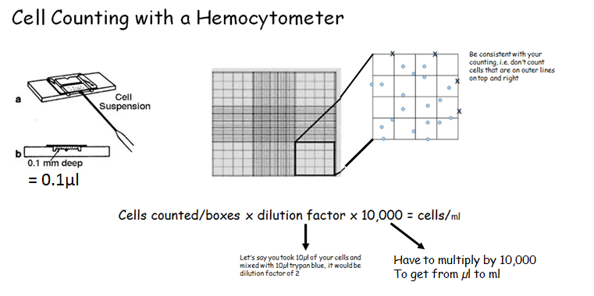

- You have trypsinized, spun down your cells and resuspended them in 5ml fresh media. You count and there are a total of 700 cells for all 4 boxes counted. You need to reseed your cells in flasks holding 5ml each. How many flasks do you need? ____7___

_700_cells/4 boxes x 2 x 10,000 = __3.5 X 10⁶_ / 5 x 10⁵ x _5___ml= ___35_ ml

35ml/5ml = 7 flasks Therefore, I will bring my 5ml solution up to 35 ml (add 30ml more media) and then put 5ml into 7 new flasks

- You have trypsinized, spun down your cells and resuspended them in 3ml fresh media. You count and there are a total of 420 cells for all 4 boxes counted. You need to reseed your cells in flasks holding 5ml each. How many flasks do you need? __________

- You have trypsinized, spun down your cells and resuspended them in 5ml fresh media. You count and there are a total of 501 cells for all 4 boxes counted. You need to reseed your cells in flasks holding 5ml each. How many flasks do you need?__________

