Marine Environmental
Study Guide for Exam 1

- Bring your IRL bouy data to class – I will look at it during exam for points!!!!!!!
- Review all Powerpoints
- Review all Chapters
- What is the scientific method? What is meant by the term “theory” in science?
- How did the Earth form?
- What was Earth’s early atmosphere like? Where did the oxygen come from? Where did the water in the oceans originally come from? How did the oceans become salty?
- What are the 4 principle oceans? What’s the difference between the oceans and seas?
- Review plate tectonics. What is a subduction zone? What is a spreading center? What features do you find at each? What is a hot spot?
- Be able to describe the 3 types of plate boundaries and features you would find at each.
- What is radiometric dating?
- Are the oldest rocks found near the mid-ocean ridge or closer to the continents?
- Be able to identify ocean floor features – continental margin, continental shelf, continental slope, abyssal plain, continental rise, trench, seamounts, sea tables)
- What is bathymetry? Can satellites map ocean floor features?
- Review the chemistry we went over. What are covalent bonds? Ionic bonds? Hydrogen bonds? What is pH? Be familiar with the pH scale. What is a buffer? What are the unique properties of water we discussed?
- What is the hydrological cycle?
- What is the thermocline? Halocline?
- Practice these short answer questions to ensure you are able to thoroughly answer them on the exam in your own words. I suggest you outline main points and then write in paragraph form. For some it might take a couple of paragraphs.
  - Why was the pattern of alternating reversals of Earth’s magnetic field, as recorded in sea floor rocks in varying distances from the mid-ocean ridge, such an important piece of evidence for advancing the theory of plate tectonics?

  - 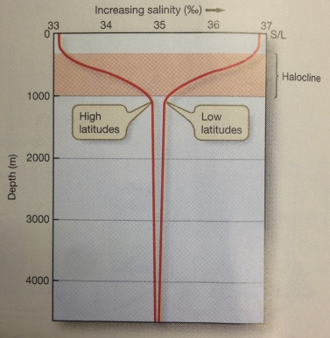 Be able to read this figure. Using the processes that affect surface seawater, explain why there is such a large range of salinity variation at the surface when comparing low and high latitudes but such a narrow range of salinity at depth.

  - Be able to describe water’s unique properties and how those properties contribute to survival of life on the planet.

