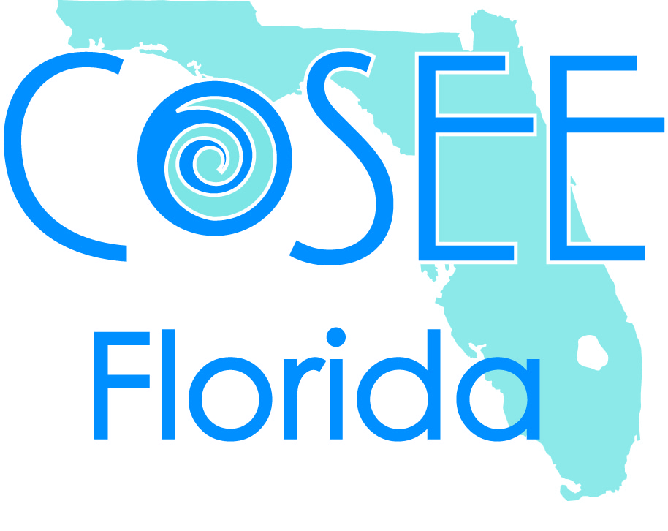
Research Experience for Pre-Service Teachers (REPT) Recommendation Form
IRSC, SUMMER 2014

Program Description
The COSEE Florida REPT program offers students and recent graduates in science education the opportunity to learn first-hand about the process of scientific discovery and research. Students from IRSC, Edison State College, and Broward College will work with local scientists on marine science research projects. Students will be paid a stipend, funded by COSEE Florida and the National Science Foundation. The students we accept this summer will work with at least one research scientist mentor and COSEE Florida staff members.

Intern Goals
- To gain valuable experience doing authentic science.
- To increase understanding of and enthusiasm for scientific research.
- To provide resources and strategies for applying REPT experience to the middle school classroom.

Eligibility
Students must be in good academic standing at the time of application and be enrolled as a junior or senior in the Bachelor of Science in Middle Grades Science Education program at IRSC, Edison State College or Broward College by the time the program begins. December 2013 graduates that have not held full-time teaching positions yet are also eligible.

To apply, students must submit two Recommendation Forms by Friday March 14th.
- One letter should be from an IRSC instructor in Science Education, an instructor from the Education Department or your Cooperating Teacher.
- The second should be from a IRSC science faculty member or your college academic advisor.
The recommending instructor or advisor must e-mail the Recommendation Form to Meghan Buckley, COSEE Florida Program Coordinator (mbuckley@irsc.edu), from their e-mail (not through the applicant) as early as possible to ensure that it is received by March 14th.

Thank you for your time and comments,

Meghan Buckley, COSEE Florida Program Coordinator
REPT Letter of recommendation
- Name of Evaluator Position
- Email of Evaluator Phone
- Name of Student
- Class Taught (year)

- I select recommendation from choices below this applicant for the COSEE Florida REPT program. (Please check the appropriate box.)

☐ Highly Recommend
☐ Recommend
☐ Do not Recommend

For the following questions, please rank the applicants proficiency on the following scale. If you are unable to comment, please answer N/A:
Needs Attention Low Developing Developing Proficient High Developing
1 2 3 4 5

- For Science Faculty and/or Advisors: Rate the student's grasp of science:
Science Concepts
Applying science concepts to the real world
Comfort level and skill in laboratory/field work

- For Education, Science Education Faculty, and/or Cooperating Teachers: Rate this student's grasp of teaching science education:
Applying best practice/best research pedagogy to a science classroom
Ability to construct science learning concepts in an effective way
Ability to teach science in the classroom

- Students will be working intensively in teams. From your observations, rate the student's qualities important to positive group dynamics:
Shares and listens to ideas in attempt to build collaborative solutions
Is responsible in meeting deadlines, communicating absences, etc.
Follows and leads in understanding diretions
Takes initiative to problem solve and keep the group moving forward.
Behaves in a professional manner

- The REPT program is designed to strengthen these future teachers understanding of real world science and research. The goal is that they will bring these experiences into the classroom with them. Rate the student's proficiency in the following areas:
ability to apply real world examples to science concepts
interest in doing scientific research

- Is there anything else you would like to add about this student? Your comments will help us identify students who will not only personally gain from the experience, but work well with a professional team of scientists and be likely to translate the REPT experience into the classroom.

TYPE COMMENTS HERE

