REPT Program Reflection Questions
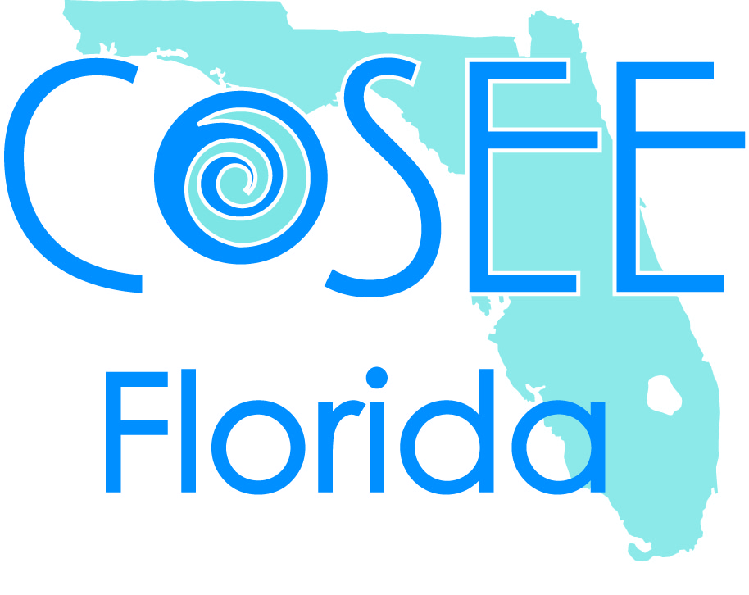

- Join COSEE Florida REPT Program’s Facebook page
- Reflections should be answered and submitted for review by 5:00 Friday each week
- Please be concise, clear, and check grammar! Reflections should be no more than a page unless specified.

Week 1
Read the assigned papers relevant to your project. List 3 questions you have about the research and bring the list to your first research day. Discuss with your mentor team.
What is the role of lab notebooks (science notebooks) at your research site? What are some key requirements for your lab notebooks?

Week 2
Talk to your mentor team about the kind of statistics you will be using to analyze your data.
What kind of observations, inferences, and predictions did you make this week? How do these differ from your scientific research hypothesis?

Week 3
Write abstract in 250 words citing 2 sources (mentor might want to modify the abstract for your poster). Remember to use CSE format for literature cited (http://irsc.libguides.com/content.php?pid=167231&sid=1409240)
What did you learn this week that you could take into the classroom?

Week 4
Interview one mentor. Discuss their pathway to their career, the connection between scientific research and K-12 education, and what message he/she would like to pass on to the next generation.

Week 5
What role does scientific research play in society? How can this role be perceived as both positive and negative? Provide examples. What steps can be taken to make scientific research more accessible and perceived positively in today’s society?

