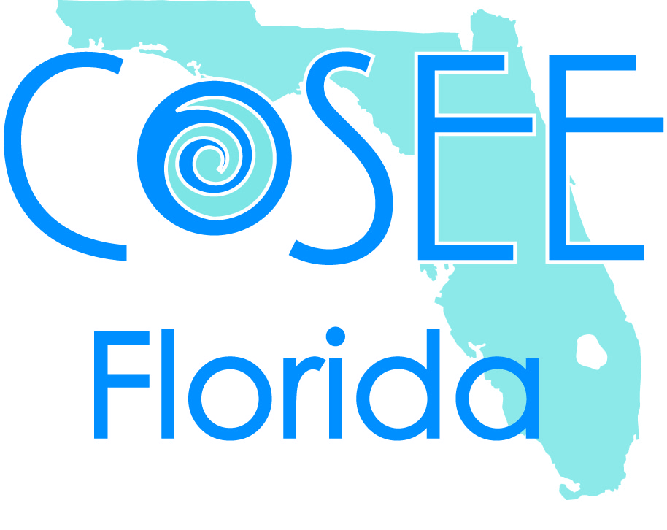
Research Experience for Pre-Service Teachers (REPT)
Indian River State College (IRSC)
SUMMER 2014

Program Description
The COSEE Florida REPT program offers students and recent graduates in science education the opportunity to learn first-hand about the process of scientific discovery and research. Students from IRSC, Edison State College, and Broward College will work with local scientists on marine science research projects. Students will be paid a stipend, funded by COSEE Florida and the National Science Foundation. The students we accept this summer will work with at least one research scientist mentor and COSEE Florida staff members.

The following are examples of research projects students participated in during last summer’s REPT program:
- Florida Oceanograghic Society (FOS): Comparison of Oyster Restoration Approaches on Oyster Growth, Survival, Condition and Associated Species.
- Smithsonian Marine Station (SMS): 1) Microbially Produced Chemical Cues for Coral Larval Settlement and 2) Secondary Metabolites of Tropical Seagrasses: A Comparative Analysis
- Harbor Branch Oceanographic Institute (HBOI) at Florida Atlantic University: 1) Feed Acceptance of Aquaculture Solids by Adult Sea Urchins, and 2) Mortality of Clams Exposed to Vibrio Bacteria
Intern Goals
- To gain valuable experience doing authentic science.
- To increase understanding of and enthusiasm for scientific research.
- To provide resources and strategies for applying REPT experience to the middle school classroom.

Eligibility
Students must be in good academic standing at the time of application and be enrolled as a second-semester junior or senior at IRSC, Edison State College, or Broward College in the Middle Grades Science or Secondary Biology Bachelor of Science degree program by the time the program begins. Recent graduates (December 2013) and former REPT alumni who have not held a full-time teaching position are also encouraged to apply.

Program Schedule
This seven-week, 175 hour program will run from Monday May 12 to Wednesday July 2, 2014. The minimum time commitment expected throughout the REPT experience will be, on average, 25 hours per week. Approximately 20 hours will be devoted to research with the remaining 5 hours spent at weekly team meetings. Research work loads will vary with the project design and may involve periods of intense work of 8 hours or more. Students involved in field work should be comfortable in and around the water and on small boats, and should expect to get wet and muddy. Rain, strong sun and insects are also common occurrences during field research.

Tentative Weekly Schedule
Week | Activity
May 12 | Orientation at IRSC
May 13-June 20 | Research
June 23-27 | Analysis, poster presentations and CSTAR completion
July 2 | Science Symposium Presentations

Required Meetings
When | Where | Topic
Wednesdays | IRSC Main Campus and/or virtually | Science research discussions and presentations. Incorporating research into science education activities/discussions.
Biweekly | TBA | Lab visits and working on CSTAR project

Required Submissions
- Reflections: Science research and education related reflections submitted weekly to the Facebook REPT Group
- CSTAR (COSEE Florida Science Teachers as Researchers) short educational video
- Scientific poster to be presented at COSEE Florida Science Symposium
- Completion and documentation of a minimum of 175 hours active participation
Continued Engagement
- You are required to participate in a minimum of one COSEE Florida sponsored and/or Water As Habitat activity
- You may have opportunities to present your research at scientific conferences

Application Requirements
In order to successfully apply to COSEE Florida's 2014 Summer REPT program, applicants must submit the following documents by March 14, 2014. The application and letter of recommendation forms are found at www.coseeflorida.org or www.jcapers-irsc.weebly.com.
- On-line application (http://www.surveymonkey.com/s/2014REPTapplication)
- Two (2) letters of recommendation sent or emailed, to Meghan Buckley (mbuckley@irsc.edu); mailbox in N220.
- Approval for IRSC college officials to access course records. Be certain to check this box on the application form.

Letters of Recommendation
In order to be eligible, recommendation letters from the following people MUST be received by March 14, 2014.
- Letter 1 - Instructor in Science Education, an instructor from the Education Department or your Cooperating Teacher.
- Letter 2 – Science faculty member or your college academic advisor.

Interviews
Required interviews will be conducted early-April. Acceptance decisions will be made by mid-April. Students who are not accepted can ask to be placed on a waiting list for any last-minute openings.

Stipends, Credit and Time Commitment
Students in the program will receive a research stipend, based on the hours they work, in three installments on or near the following dates: June 13, June 30, and July 15.

Health Insurance
Students who are accepted must provide evidence of health insurance prior to the first day of activities.

