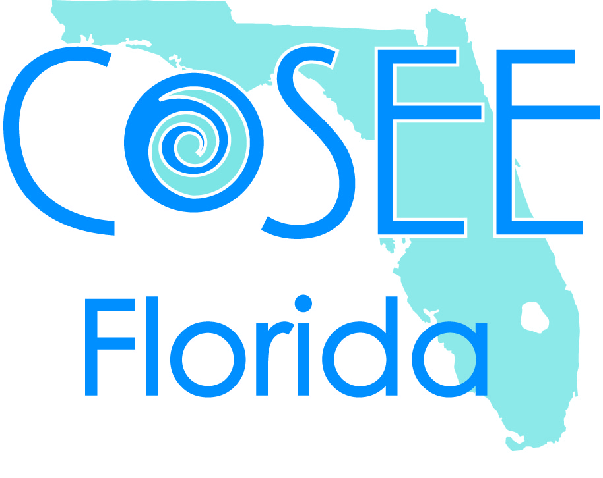
IRSC/REPT Program
RESEARCH PROJECT PROPOSAL GUIDELINES

Purpose: Share your current progress and future goals for your research. Provide you with a basic outline for your poster.
Practice presenting your research.
Audience: REPT interns, mentors, staff and instructors
Time: 5 minutes (no more!)

- Clear statement of research question
  - Very clearly state what you will be studying.
  - This could be modified into your Title for your final poster.

- Background/Statement of the Problem/Significance of the Project
  - Clearly support your statement with documentation and references (Capers et al. 2006), and include a review of the literature that supports the need for your research or creative endeavor. A discussion of present understanding and/or state of knowledge concerning the question/problem or a discussion of the context of the scholarly or creative work.
  - If your project is a portion of a larger project, the background should describe the research in general, on a large scale, but the Project Description should be mostly about what you are going to do.
  - This could be used/modified into your Introduction for your final poster.

- Experimental/Project Design
  - This section of the proposal should explain the details of the proposed plan. How will you go about exploring your research question? What will be your methods? If you are not the only person working on the project, who else will be involved? Be specific on what you plan on doing.
  - This can be modified and updated into your Material and Methods for your final poster.

- Project timeline
- Anticipated results
  - Are there any? Are there any expectations?
- Literature Cited
  - CSE Format - http://irsc.libguides.com/content.php?pid=167231&sid=1429621

Develop/write your proposal that you will use for you presentation. If using Powerpoint, include key statements, methods, etc. that you will be discussing (don’t clutter slides with a lot of words) – be sure to include pictures you have already taken. A few slides will be sufficient. Remember, this is a good way to prepare information that you will be using to write the components of your poster and CSTAR.

