Oceanography 2001
Homework Assignment for Exam 1
Turn in on the day of Exam 1 Name:

- Label A-E on this figure:

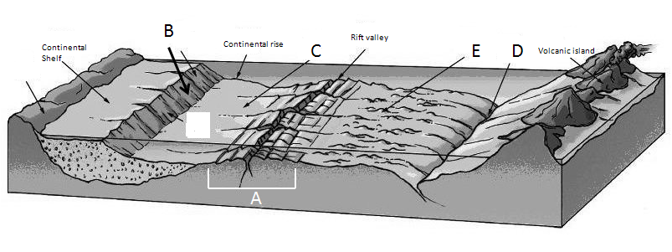

- Write whether the following are associated with a subduction zone or spreading center:
- island arc ___________________________

- mid-ocean ridge ___________________________

- developing seafloor magnetic stripes ___________________________

- seafloor spreading ___________________________

- trench ___________________________

- What are the 4 principle oceans of the Earth?

- Label the layers of the Earth:
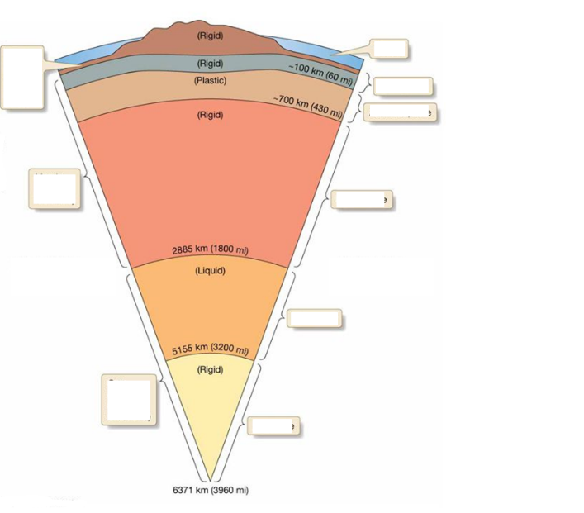

- Describe convergent, divergent and transform boundaries.

- How old is the Earth? __________________________
- What is radiometric dating?

- What are the steps of the scientific method?

- What are autotrophic organisms? Heterotrophic organisms?

- What is some of the evidence for seafloor spreading?

- What is some of the evidence for continental drift?

