OCE 2001
Chapter 9 – Tides Name:

For these assignments, read the chapter in your book and review the powerpoint on the website.

- What is gravitational force?

- What is centripetal force?

- What are resultant forces?

- Label:
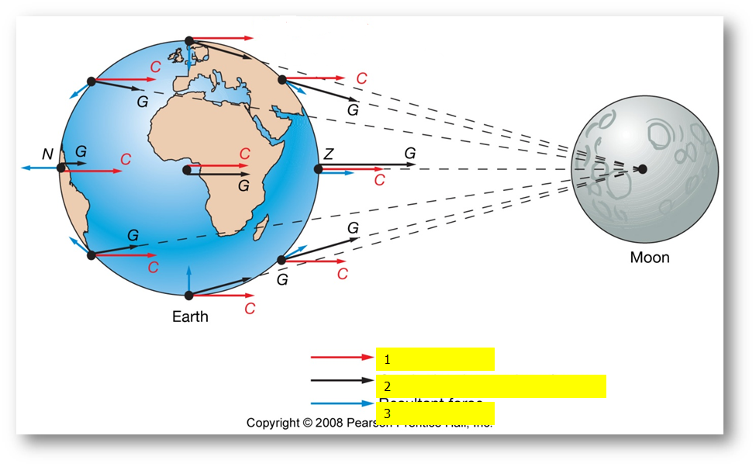
- ____________________________
- ____________________________
- ____________________________

- Why is a lunar day 24 hours and 50 minutes long, while a solar day is 24 hours?

- Draw the position of the Moon and the Sun during a Spring Tide:

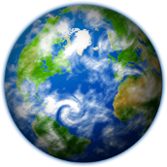

- Draw the position of the Moon and the Sun during a Neap Tide:

- Draw a picture showing perihelion and aphelion.

- Draw a picture showing apogee and perigee.

- Are the tides considered deep water waves or shallow water waves? _______________

- What is an amphidromic point?

- In theory, most coastal regions on Earth should experience 2 high tides and 2 low tides per day. However, the depth and size of nearby ocean basins, distance from amphidromic points, etc can result in different tidal patterns. What are these tidal patterns?

- Using the internet, find the tidal prediction for Fort Pierce for your birthday this year.

- What causes whirlpools?

