OCE 2001
Chapter 8 – Waves Name:

- How are most ocean waves generated?

- Define fetch.

- Describe the 3 types of motion in which progressive waves move. Which type includes waves at the ocean surface?

- Label:
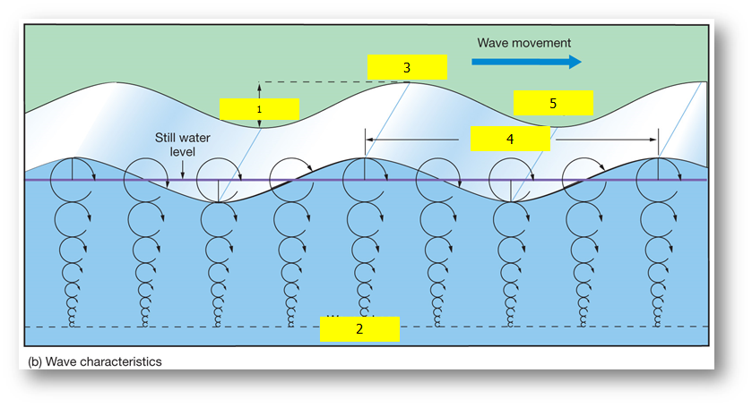
- ___________________________
- ___________________________
- ___________________________
- ___________________________
- ___________________________

- What is wave steepness? What is the formula to calculate wave steepness?

- When will a wave “break”?

- What are deep water waves?

- What are shallow water waves?

- Is the “60 foot rule” correct or incorrect?

- What are interference patterns?

  - What is constructive interference? Define and label on figure below.

  - What is destructive interference? Define and label on figure below.

  - What is mixed interference?

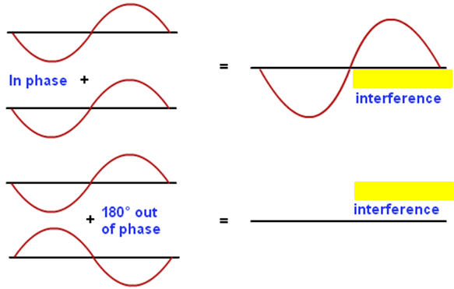
- What is a rogue wave?

- How are rogue waves thought to be caused?

- What is the surf zone?

- What are the 3 main types of breakers?

- What is a tsunami? How is it generated?

- Is a tsunami considered to be a shallow water wave or deep water wave?

