OCE 2001
Chapter 10 and 11 – Coastal Ocean and Marine Pollution

For these assignments, read the chapters in your book and review the powerpoints on the website.

- Label:

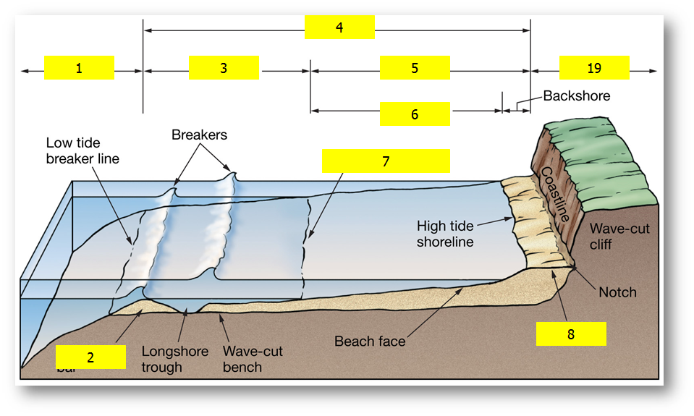
- _____________________________
- _____________________________
- _____________________________
- _____________________________
- _____________________________
- _____________________________
- _____________________________
- _____________________________
- _____________________________

- Describe the differences between summertime and wintertime beaches. Explain why this occurs.

- What is longshore drift?

- What is an erosional shore?

- Label:

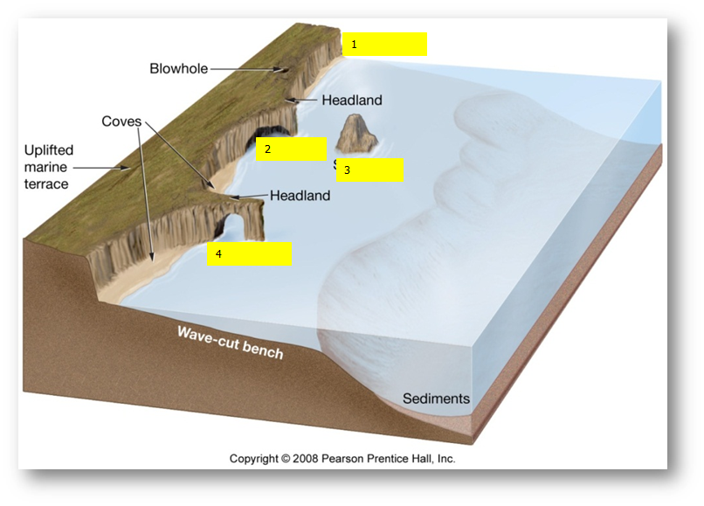
- ___________________________
- ___________________________
- ___________________________
- ___________________________

- What is a depositional shore?

- What is a barrier island?

- Does a barrier island move over time?

- What factors can effect sea level?

- Humans try to stop the dynamic nature of the beach when they want to protect man-made structures that we have built there.
  - What type of hard stabilization does this figure represent?
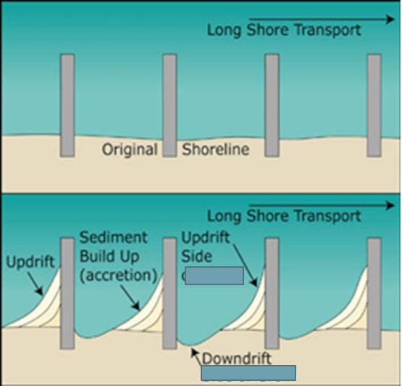
  - What type of hard stabilization does this figure represent?
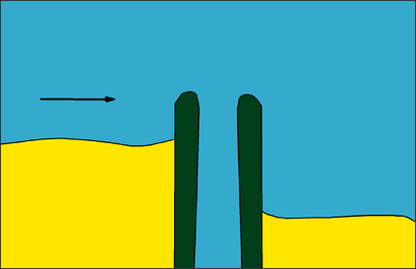
  - What type of hard stabilization does this figure represent?
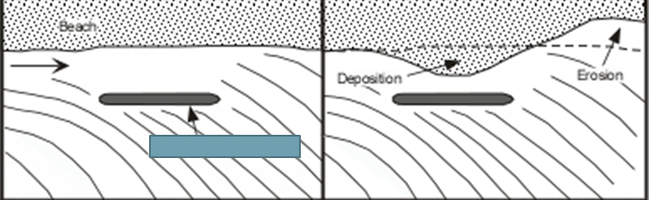

- What is an estuary?

- Explain why salinity and temperature can fluctuate more in a coastal region or estuary compared to the open ocean.

- What are the 4 types of estuaries based on geologic origin?

- What are lagoons?

- What are marginal seas?

- Areas like the Indian River Lagoon are often called the nurseries of the ocean, why?

- Coastal wetlands: where would you find a salt marsh? Where would you find mangrove swamps?

- How do wetlands contribute the biology of the oceans and cleansing of polluted river water?

- Examine the World Health Organization’s definition of pollution – why does it need to be so specific?

- What is an environmental bioassay?

- Explain why marine pollution experts consider oil among the least damaging pollutants in the ocean.

- Discuss techniques used to clean oil spills?

- Why are oil spills dangerous for marine life?

- What is sewage sludge?

- What is DDT?

- What are PCBs?

- Where does a lot of the mercury pollution come from in the ocean?

- What is this figure describing?
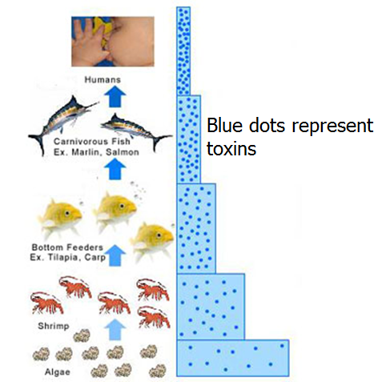

- What is non-point source pollution?

- What are some issues that marine life face with plastic pollution?

- What is biological pollution?

