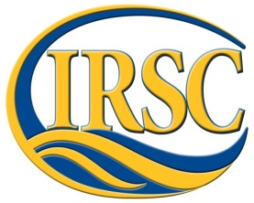 Current Issues in Marine Environmental Science 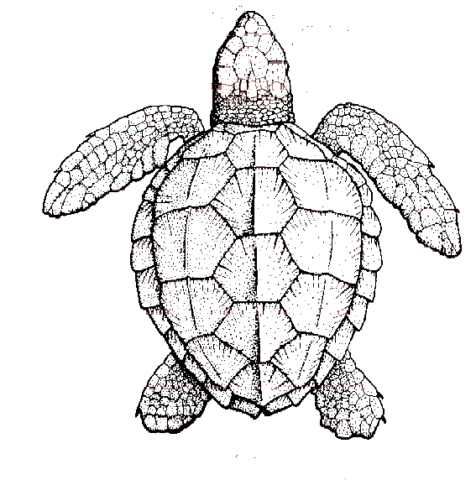
INDIAN RIVER STATE COLLEGE COURSE SYLLABUS
COURSE NUMBER: OCB 3017
Summer I and II 2015

Instructor: Dr. Jennifer Capers
Office: N-212 (Main)
Office hours: Check schedule on website
E-mail: jcapers@irsc.edu
Required Textbook: Essentials of Oceanography, 11th ed., Trujillo and Thurman.
Websites: Blackboard, My website: www.jcapers-irsc.weebly.com

TENTATIVE SCHEDULE – Subject to change!!!!!!
This course runs through Summer I and II. We will meet face-to-face majority of the time during Summer I (pay attention to dates since there will be times I cannot meet due to other commitments) and only some during Summer II. During Summer II, we will not meet face to face as much – this will be time for you to write/complete your review research paper and project.

Day | Topic | Reading | Ocean Literacy Principle(s)  2013
May 5 | Introduction, Review of Geology of the Ocean | Chapter 2, 3  Handouts/Powerpoint | 1a, 1b, 2a, 2e
May 7 | Cont., FL Geology, FL Sediments | Chapter 2,3,4  Handouts/Powerpoint | 1a, 1b, 2a, 2e
May 14 | FL Hydrological Environment, Salt Water Intrusion | Handouts/Powerpoint | 1e
May 19 | EXAM 1 in Testing Center May 18 and 19  Natural Communities of FL | Handouts/Powerpoint | 5a, 5c, 5d, 7f
May 21 | Marine Life, Primary Productivity | Chapter 12-15  Handouts/Powerpoint | 5a, 5c, 5d, 7f  2d, 3e, 4a, 4b, 5b, 5g, 6d
June 2 | Cont. Primary Productivity
June 9 | cont
June 11 | EXAM 2 in Testing Center June 8 and 9  Indian River Lagoon | Chapter 10  Handouts/Powerpoint | 1g, 5i, 6d
June 16 | Issues Facing KOE Watershed  Fish Kill | Chapter 11  Handouts/Powerpoint | 1g, 1h, 6d, 7c
June 18 | Cont. Watershed Issues
June 23 | Exam 3 in Testing Center June 17 and 18  Climate Change | Chapter 16  Handouts/Powerpoint | 1c, 1d, 2d, 3f, 3g, 6a
June 25 | Cont. Climate Change
June 30 | Ocean Acidification | Chapter 5  Handouts/Powerpoint | 1e, 5f, 6e
Week of July 6 | EXAM 4 and Comprehensive Final in Testing Center
Research Paper Dates: | Topic and 2 literature sources – due 5/19  Final Draft – due week of July 6th  Final Paper – due July 30
Design Newly Discovered Marine Species | We will set up meeting time during Summer II for everyone to come in and present

Learning Outcomes:
At the successful end of this course, the student will be able to:
- Apply critical thinking skills based on collecting, analyzing, and drawing conclusions based on data.
- Recognize that there is one world ocean that contains majority of the livable space on the planet.
- Describe basic physical, chemical, and geological features of the ocean and coastal systems dealing with currents, tides, temperature, pH, geological features and biological zonation.
- Explain the ocean’s effect on climate and be able to discuss the concept of climate change.
- Identify the various habitat zones of the ocean.
- Identify major groups of organisms found in the ocean and coastal aquatic systems.
- Explain human impacts on the ocean.

COURSE STRUCTURE AND POLICIES: (please read carefully)
In order to do well in this course, you will be expected to attend all lectures, take good notes, actively participate in the in-class exercises and discussion, and read the assigned material.
- Class Meetings – Attendance is mandatory! It is important you are present in order to receive all of the information. Also, we will have various discussions on marine issues as well as presentations/exercises that you will have to be present for.

- Data and summary of research papers homework - You will be required to still collect data from the Kilroys like you did during OCB 2010. I will also provide you with primary literature sources dealing with marine topics – you will read and summarize the papers

- Review Research Paper and “Design a Newly Discovered Marine Species” project – This will be done during Summer II.

- Examinations – 3 100pt Exams (essay, short answer, matching) will be given throughout the semester. You will be allowed to drop your lowest score (there will be NO make-up exams). A 200pt exam 4 and comprehensive final (that cannot be dropped!) will be given at the end of the semester. The exams will be based on the material presented in class (including anything posted on Blackboard, handouts, etc.) and on the assigned readings.

MAKE-UP POLICY: No make-up exams will be given (that’s why I give a drop exam). Contact instructor before exam if you plan to miss it.

Points  3 Exams (lowest score dropped) 200  Final Exam 200  Homework/Paper/Project 200  Total: 600 | Grading Scale  A= 90-100%  B= 80-89%  C= 70-79%  D= 60-69%  F= >60%
Last day to withdraw – June 28th
EXTRA CREDIT: No extra credit is given. Students need to spend their time on required material.

Cheating: Cheating, including plagiarism and cell phone use during exams, of ANY kind will not be tolerated by this department. Any student caught cheating will receive an immediate F on the assignment – possibly the course.

DISABILITIES POLICY:
Indian River State College provides reasonable accommodations to students with documented disabilities through the Educational Services Division / Student Disability Services Office. The rights of students with disabilities which pertain to post-secondary education are provided under Section 504 of the Rehabilitation Act of 1973 and the Americans with Disabilities Act (ADA) of 1990. These laws prohibit discrimination by institutions to "otherwise qualified" students with disabilities. This enables such students to have an equal opportunity to benefit from the education offered by those institutions.

DISCRIMINATION POLICY: Indian River State College does not discriminate on the basis of race, color, national origin, ethnicity, sex, religion, age, disability, sexual orientation, marital status, veteran status or genetic information in its programs and activities.

