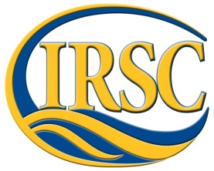 Marine Environmental Science 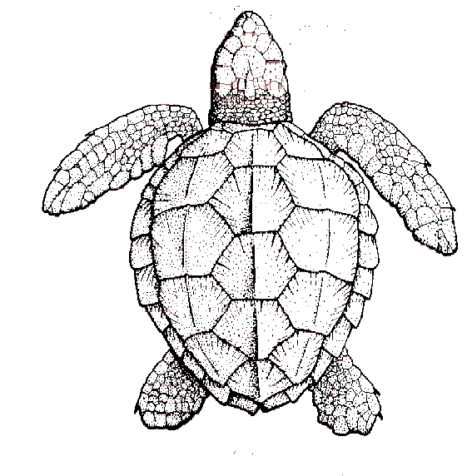
INDIAN RIVER STATE COLLEGE COURSE SYLLABUS
COURSE TITLE: Marine Environmental Science COURSE NUMBER: OCB 2010
Spring 2015

Instructor: Dr. Jennifer Capers
Office: N-212 (Main)
Office hours: Check schedule
E-mail: jcapers@irsc.edu
Required Textbook:
Essentials of Oceanography, 11th ed., Trujillo and Thurman.

TENTATIVE SCHEDULE – dates are subject to change with appropriate notification from the instructor

Week of | Topic | Reading | Ocean Literacy Principle(s)  2013
Jan 5 | Introduction to Planet Earth | Chapter 1 | 1a, 2a, 5e, 7a
Jan 12 | Plate Tectonics and the Ocean Floor | Chapter 2 | 1b, 2e
Jan 19 | Monday Holiday, Marine Provinces | Chapter 3 | 1b, 5f
Jan 26 | Water and Seawater  Exam 1 (Chapter 1, 2, 3, 5) | Chapter 5 | 1e, 1g
Feb 2 | Marine Life and the Environment, Productivity | Chapter 12, 13 | 2d, 4b, 5a, 5b, 5c, 5d, 5e, 5f, 6e  3e, 4a
Feb 9 | Pelagic Animals, Benthic Animals | Chapter 14, 15 | 5a, 5b, 5c, 5d, 5e, 5f  5g
Feb 16 | The Coastal Ocean | Chapter 11 | 1g, 1h, 5i, 6f, 7c
Feb 23 | Exam 2 (Chapter 11, 12, 13, 14, 15), Marine Sediments | Chapter 4 | 2c, 2d
Mar 2 | Air-Sea Interactions, Climate | Chapter 6, 16 | 1f, 3a, 3b, 3c, 3d, 3f
Mar 9 | Ocean Circulation | Chapter 7 | 1c, 1d
Mar 16 | Spring Break
Mar 23 | Cont, Exam 3 (Chapter 4, 6, 7, 16)
Mar 30 | Waves | Chapter 8 | 2c
Apr 6 | Tides | Chapter 9 | 5h
Apr 13 | Beaches and Shoreline, Review | Chapter 10 | 2c
April 20 | Comprehensive Final (2 parts)

Learning Outcomes:
At the successful end of this course, the student will be able to:
- Apply critical thinking skills based on collecting, analyzing, and drawing conclusions based on data.
- Recognize that there is one ocean that contains majority of the livable space on the planet.
- Describe basic physical, chemical, and geological features of the ocean and coastal systems dealing with currents, tides, temperature, pH, geological features and biological zonation.
- Explain the ocean’s effect on climate and be able to discuss the concept of climate change.
- Identify the various habitat zones of the ocean.
- Identify major groups of organisms found in the ocean and coastal aquatic systems.
- Explain human impacts on the ocean.

COURSE STRUCTURE AND POLICIES: (please read carefully)
In order to do well in this course, you will be expected to attend all lectures, take good notes, actively participate in the in-class exercises and discussion, and read the assigned material.
- Class Meetings – Attendance is mandatory! It is important you are present in order to receive all of the information. Also, we will have various discussions on marine issues as well as presentations/exercises that you will have to be present for.

- Lectures and Readings - The reading assignments in the textbook will parallel the lecture material. If you keep current with the readings, then you will get more out of the course and you'll also have an easier time preparing for the exams. It is to your advantage to read the material before class.

- Homework Assignments – These will be given throughout the semester. These assignments will include working with data sets, graphing, answering questions, research, etc. Points will be deducted for late work.

- Examinations – 3 100pt Exams (essay, short answer, matching) will be given throughout the semester. You will be allowed to drop your lowest score (there will be NO make-up exams). A 200pt comprehensive final will be given at the end of the semester. The exams will be based on the material presented in class (including anything posted on Angel) and on the assigned readings.

MAKE-UP POLICY: No make-up exams will be given. Contact instructor before exam or quiz if you plan to miss it.
Points  3 Exams (lowest score dropped) 200  Final Exam 200  Homework/Assignments 200  Total: 600 | Grading Scale  A= 90-100%  B= 80-89%  C= 70-79%  D= 60-69%  F= >60%
Last day to withdraw – March 24th
EXTRA CREDIT: No extra credit is given. Students need to spend their time on required material.

Cheating: Cheating, including plagiarism and cell phone use during exams, of ANY kind will not be tolerated by this department. Any student caught cheating will receive an immediate F on the assignment – possibly the course.

Cell phone use: The use of cell phones is prohibited during class at IRSC. All cell phones must be set on silent or off during the class period. Any student who uses a cell phone to make or answer a call, or send and read text messages or emails, other than IRSC emergency messages during class time may be asked to leave and may be considered absent for that class. No student has the right to disturb the teaching and learning process.

STUDENTS WITH DISABILITIES: Indian River State College provides reasonable accommodations to students with documented disabilities through the Educational Services Division / Student Disability Services Office. The rights of students with disabilities which pertain to post-secondary education are provided under Section 504 of the Rehabilitation Act of 1973 and the Americans with Disabilities Act (ADA) of 1990. These laws prohibit discrimination by institutions to "otherwise qualified" students with disabilities. This enables such students to have an equal opportunity to benefit from the education offered by those institutions.

If you are experiencing difficulty in your course, your first obligation is to work directly with your instructor to resolve the issue. If you are unable to settle your concerns with the assistance of your instructor, you can contact the Department Chair (Sherry Bowen, x7502), who will assist you or advise you about contacting the Academic Dean (Dr. Paul Horton, x7503) or Vice President (Dr. Tony Iacono, x7215).

