Cell Biology and Physiology Lab
Mitosis Name:

Use the slides to find cells in each of the stages of mitosis. Take pictures of each.

What is the MTOC?

Interphase
What is happening during Interphase?

Draw Interphase

Paste your picture of Interphase:

Prophase
What is happening during prophase?

Draw Prophase
Paste your picture of Prophase:

Prometaphase
What is happening during Prometaphase?

Draw the figure on slide 13.

Metaphase
What is happening during metaphase?

Draw Metaphase:
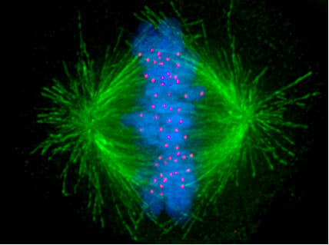
Paste your picture of metaphase:

Anaphase
What is happening during anahase?

Draw anaphase:
Paste your picture of anaphase:

Telophase
What is happening during telophase?

Draw telophase:
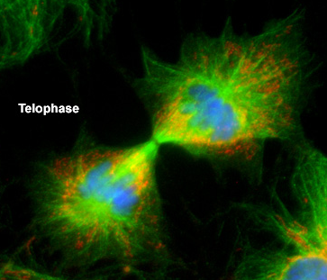
Paste your picture of telophase:

