MCB2010L –Microbiology Lab
Exercise 9: The effects of Radiation on Growth
  - UV radiation is most effective at 260 nm.
  - The UV light causes thymine dimers within DNA of the cell (Figure 9-2). Distortion of the DNA molecule will occur, and the cell may be unable to replicate or transcribe its DNA properly.
  - Vegetative cells are sensitive to UV light, while spores are somewhat resistant.
  - The UV light can be used to disinfect the air and surfaces when the room are not in use because the harmfulness to human.
  - Work in pair; procedure – page 57
    - Inoculate 2 TSA plates; one with S. aureus and the other with B. subtilis. Can you think of the reason why we are comparing these two organisms?
    - Mark the bottom of the plate with permanent marker to divide the plate in two equal halves. Mark “X” on the side that was covered by the index card.
    - Expose your plates under UV light for the timed assigned. *****Take off the lid (unless specified by the instructor) and cover half of the plate with index card (Figure 9-4).
    - Remove from the UV light after assigned time of exposure. Incubate overnight.
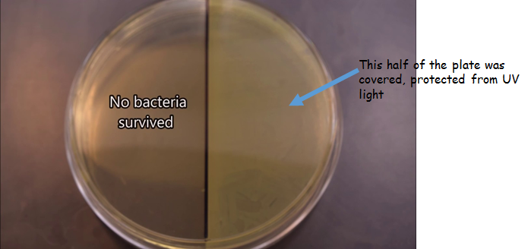

Exercise 10: Evaluation of Antiseptics
  - Disinfectants and antiseptics are antimicrobial agents.
  - Disinfectants kill or inhibit growth of pathogenic organisms but are too harsh to use on living tissues.
  - Antiseptics do not harm living tissues.
  - Work in pair; procedure – page 63
    - Inoculate 2 TSA plates; one with S. epidermidis and the other with Ps. aeruginosa. Can you think of the reason why we are comparing these two organisms?
    - Mark the bottom of the plate with permanent marker to divide the plate into 4 quadrants. Label each with “alcohol”, “iodine”, “peroxide”, and mouth wash”.
    - Dip the paper disc using sterilized forceps into appropriate antiseptic and allow excess liquid to fall back into beaker.
    - Place the disc on the surface of the inoculated TSA in the center of the quadrants.
    - Incubate overnight and measure zone of inhibition (Figure 10-1) the next period.
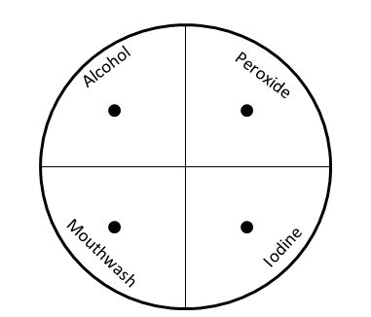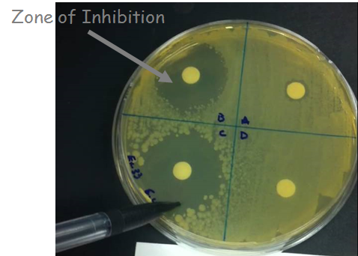
Exercise 11: Importance of Hand Washing
  - Extraneous organisms: usually superficial and transient, can be removed by a thorough hand washing.
  - Normal flora: live deeper in the skin, normally harmless and compete invading extraneous, protecting us from skin pathogen.
  - Common skin flora includes S. aureus, S. epidermidis, and yeast.
  - These can cause infection if break into the skin or the body cavity during surgery. Extensive scrubbing and the use of antibacterial substance and gloves are required before surgeries.
  - Work in groups of four; procedure – page 69
    - Mark the bottom of the plate with permanent marker to divide the plate into 2 equal halves. Label “washed” and “unwashed”.
    - Place central three fingers on the surface of agar in the “unwashed” section.
    - Wash as assigned; bar soap and scrub brush, liquid soap, waterless hand sanitizers, and 10% chlorine solution.
    - Allow to dry and press on the “washed” side of the plate.
    - Incubate overnight and check the results on next period.

