MCB2010L –Microbiology Lab
Exercise 15: Bacterial Identification of Enterobacteriaceae Using EnteroPluri System
  - The EnteroPluri is a biochemical identification system for the identification of members of the Enterobacteriaceae family.
    - Enterobacteriaceae are gram negative, oxidase negative
    - They are facultative anaerobes – they ferment but are not killed in the presence of oxygen
    - Include E.coli, Salmonella, Yersinia, Klebsiella, Pseudomonas, Shigella
  - The tube is a self-contained, compartmented plastic tube containing twelve different media that allow determination of 15 biochemical reactions.
    - For example: does the bacteria ferment glucose and produce gas?; does the bacteria ferment lactose?; does the bacteria use citrate?
    - Combination of answers to these questions can indicate what bacteria you are dealing with.
  - When would you use the EnteroPluri tube?
Is the bacteria in question gram -? | YES | NO
Is the bacteria bacillus in shape? | YES | NO
Is the bacteria oxidase negative?  - Cytochrome oxidase is what is used at end of electron transport chain  - Enterobacteriaceae don’t need this because they are anaerobic | YES | NO
 | If you have circled YES for all, then you can use the EnteroPluri tube to further characterize/identify your unknown

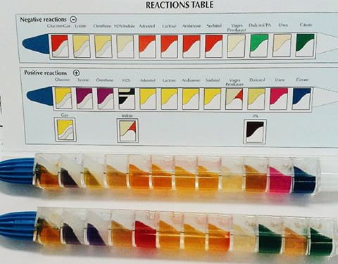
  - Work in pairs
    - Obtain one EnteroPluri tube.
    - Inoculate the tube with unknown bacteria.
    - Incubate overnight and interpret all reactions in the next period- page 96-98.
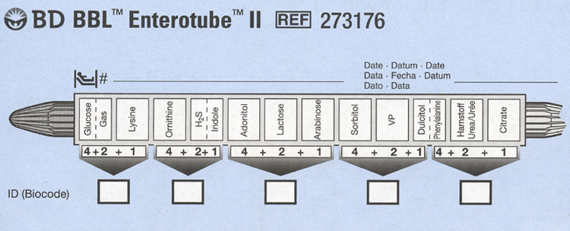

Exercise 16: Antibiotic Sensitivity Using the Kirby-Bauer Method
  - Once the pathogen has been identified, the physician will select an appropriate drug for the effective treatment of the disease.
  - The Kirby-Bauer is a highly standardize disc diffusion method that is approved for wide use in clinical laboratories.
  - Work in pair; procedure – page 102
    - Obtain two Muller-Hinton agar plates.
      - Why Muller-Hinton? This agar grows a variety of microbes. Also detoxifies toxins that the bacterial release which might alter antibiotic results.
    - Inoculate one plate with Pseudomonas aeruginosa and the other plate with Staphylococcus aureus.
    - Place BBL discs using dispenser.
    - Incubate the plates overnight
    - Examine plates and measure zones of inhibition in mm and compare with the chart provided – page 104-105
      - Just because there is a zone of inhibition does not mean that the bacteria is sensitive to the antibiotic – it all depends on the species and the antibiotic (that’s why it’s important to measure the zone and compare to the chart)
