MCB2010L –Microbiology Lab
Exercise 15: Bacterial Identification of Enterobacteriaceae Using EnteroPluri System
  - The EnteroPluri is a biochemical identification system for the identification of members of the Enterobacteriaceae family.
    - Enterobacteriaceae are gram negative, oxidase negative
    - Include E.coli, Salmonella, Yersinia, Klebsiella, Pseudomonas, Shigella
  - It is self-contained, compartmented plastic tube containing twelve different media that allow determination of 15 biochemical reactions.
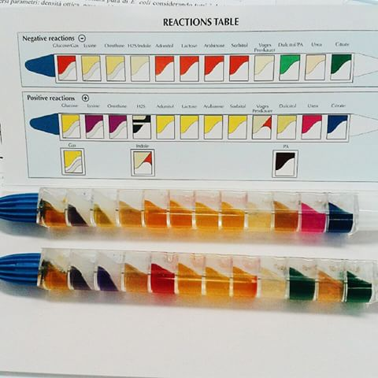
  - Work in pairs
    - Obtain one EnteroPluri tube.
    - Inoculate the tube with unknown bacteria.
    - Incubate overnight and interpret all reactions in the next period- page 96-98.
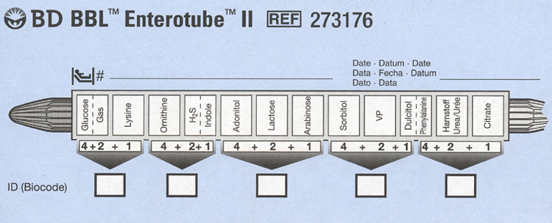

Exercise 16: Antibiotic Sensitivity Using the Kirby-Bauer Method
  - Once the pathogen has been identified, the physician will select an appropriate drug for the effective treatment of the disease.
  - The Kirby-Bauer is a highly standardize disc diffusion method that is approved for wide use in clinical laboratories.
  - Work in pair; procedure – page 102
    - Obtain two Muller-Hinton agar plates.
      - Why Muller-Hinton? This agar grows a variety of microbes. Also detoxifies toxins that the bacterial release which might alter antibiotic results.
    - Inoculate one plate with Pseudomonas aeruginosa and the other plate with Staphylococcus aureus.
    - Place BBL discs using dispenser.
    - Incubate the plates overnight
    - Examine plates and measure zones of inhibition in mm and compare with the chart provided – page 104-105
      - Just because there is a zone of inhibition does not mean that the bacteria is sensitive to the antibiotic – it all depends on the species and the antibiotic (that’s why it’s important to measure the zone and compare to the chart)
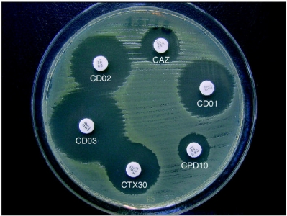
Exercise 17: Differentiation of Staphylococcus Species
  - S. aureus is the most common species to cause Staph infection.
  - S. aureus is catalase positive which distinguishable from Enterococci and Streptococci.
  - Disease associated strains produce toxins, and express cell-surface proteins (Protein A) that bind and inactivate antibodies.
  - S. aureus also produces coagulase, an enzyme that is a clotting factor. The fibrin clot allows S. aureus to wall itself off and making it harder to detect by immune system.
  - Coagulase and Staphyloslide test are performed to differentiate S. aureus from other Staphylococci
  - Work in pairs; procedure – page 108-109
    - Staphyloslide test - Inoculate the S. aureus and S. epidermidis by mixing with test latex reagent.
      - If agglutination occurs, that means that Protein A is present on the bacteria
    - Coagulase test - Inoculate the S. aureus and S. epidermidis into rabbit plasma tubes.
      - The plasma will coagulate if the bacteria is producing coagulase

