MCB2010L –Microbiology Lab
Week 2: Darkfield and Phase Microscopy
- Darkfield Microscopy
  - Simple yet effective technique used to observe live and unstained specimens
  - Only light scattered by the specimen goes on to produce image, whereas directly transmitted light is omitted (giving the appearance of a dark background)
  - How to prepare scope: remove blue filter, attach dark field adapter
  - Make wet mount of pond water, observe
- Phase-Contrast Microscopy
  - Able to differentiate the transparent protoplasmic structures and enhance the contrast between a cell and its surroundings without staining
    - Staining usually results in cell death
  - Utilizes phase-shift of light’s wavelength
- Both of these microscopic techniques are used to observe motility in live specimens
Exercise 4: Motility
- Motility Determination
  - Major organelles of motility in bacteria are flagella (some have it, some do not)
    - Allows cells to move toward nutrients or away from harmful substances
  - Motility and arrangement of flagella around the cell are important taxonomic characteristics that are useful in characterizing bacteria
    - Differentiating between true swimming motility and Brownian motion
      - Brownian motion is movement that is due to molecular bombardment or currents under cover glass of slide, not true movement

  - 2 methods we will use today:
    - Wet mount
      - Look at slide immediately so it doesn’t dry out
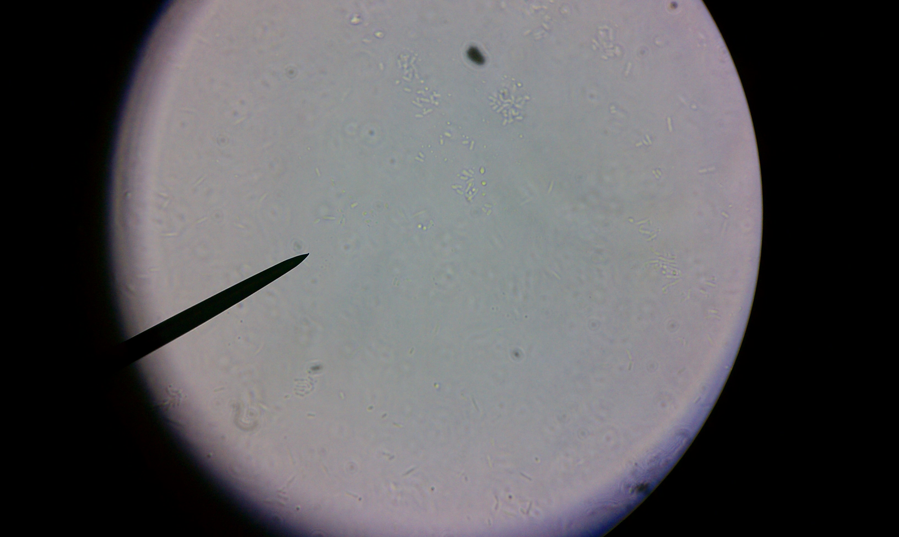
      - Focus – make sure condenser is down, focus on edge of air bubble, focus on 40x, bacteria will be right outside air bubble
      - Bring condenser up, push the phase-contrast adapter into condenser
      - Advantage: immediate; Disadvantage: can dry fast, may have to handle pathogenic bacteria
    - Culture method
      - Using semi-solid agar
        - Be sure not to shake and disturb agar
        - Inoculate agar with specimen (straight in, straight out)
        - Incubate at room temp
      - Advantage: don’t have to handle wet mount of possible pathogenic bacteria; Disadvantage: takes time to incubate
Activitites
- Learn how to change from Brightfield to Darkfield and Phase Contrast.
- Making wet mount slide using pond water, observe and compare between Brightfield to Darkfield and Phase Contrast.
- Inoculate Staphylococcus aureus and Pseudomonas aeruginosa into motility agar. Observe the result the following week.
- Making wet mount slide with Staphylococcus aureus and Pseudomonas aeruginosa and observe the motility using Phase Microscopy.

