Mammalian Tissue Culture
Quick Reference Guide

Good Aseptic Technique and Materials Needed
Laminar Flow Hoods | Turn UV light on for period of time before use  Swab down with alcohol | Don’t share hood with micro  Don’t clutter hood
Glassware | Beakers, flasks, etc  Wash according to tissue culture protocol  Always a good idea to cover glassware with foil and then autoclave | Don’t share glassware with other laboratory procedures
Tissue Culture Flasks | Keep sterile until use
Incubator with CO₂ | Clean regularly | Don’t share incubator with micro
Warm water bath | Clean regularly | Don’t share with micro
Media and other reagents (like fetal bovine serum, trypsin, PBS) | Depends on cell line what the requirements are  Might need added vitamins, etc  Always aliquot out the media and reagents in amounts typically used to cut down on possible contamination  Always put your initials and the date of opening on bottle | Don’t ever open a bottle unless under the hood
Pipettes | Keep sterile until use
15ml and 50ml centrifuge tubes | Keep sterile until use
Biohazard containers
Spray bottles with alcohol
Drying oven
Centrifuge
Inverted microscope

Sterilization of Glassware
- Materials needed:
  - Disinfectant: Hypochlorite
  - Detergent: i.e. Decon
  - Deionized water
  - Soaking baths (containers)
  - Bottle brushes
  - Drying oven
  - Autoclave tape
  - autoclave
- Procedure:
  - Allow soaking in detergent overnight
  - Scrub with brush and rinse (couple rinses using tap water, then rinse using deionized water)
  - Put in drying container
  - Place in drying oven (if available)
  - Autoclaving:
    - Cover the top of glassware with foil
    - Place a piece of autoclave indicator tape on top
    - Autoclave

Sterilization of small amounts of liquid (additives for media) using syringe tip filter
- Materials
  - Plastic syringe (10-15ml)
  - Syringe tip filter
  - Receiver vessel (centrifuge tube or something)
- Procedure
  - Done under the hood!
  - Fill syringe with the fluid to be sterilized (vitamins, or antibiotic, etc)
  - Unpack sterile filter and place on tip of syringe (don’t touch the tip!)
  - Expel liquid slowly through filter

Sterilization of media, PBS, etc using vacuum filter flask
- Materials:
  - Filter flask with lower chamber (such as a Nalgene filter unit, 500ml), keep sterile
  - Vacuum pump
- Procedure:
  - Done under the hood!
  - Hook up pump
  - Pour nonsterile media into top filter chamber
  - Turn on vacuum pump
  - Take the top filter chamber off and cap bottom that now contains sterile media
  - Label container

Feeding a monolayer culture in flasks
- Materials:
  - Media
  - Pipettes
  - Waste jar
- Procedure
  - Done under the hood! Make sure to prepare the hood properly
  - Warm media in warm water bath (spray with alcohol before placing bottle in hood)
  - Examine the culture first under the microscope to make sure it looks healthy
  - Take back to hood and loosen cap to flask (stand flask upright)
  - Pipette off old media and discard
  - Discard pipette
  - Using new sterile pipette, add new media to NEW flask (or other dish)
  - Return to CO2 incubator
Feeding a suspension culture
- These cells are not adhered to the flask or petri dish. Therefore, you must pipette your cell solution, place in 50ml centrifuge tube and centrifuge. Then bring the tube back to the hood, discard the old media, and then resuspend the cell pellet in new media

Subculture of monolayer cells
- Materials:
  - Media
  - Trypsin (0.25% in D-PBSA) – kept frozen
  - Sterile PBS
  - Pipettes
  - Waste jar
  - 50ml Centrifuge tubes
  - Centrifuge
- Procedure:
  - Done under the hood! Make sure to prepare the hood properly
  - Warm media and trypsin in warm water bath (spray with alcohol before placing under hood)
  - Discard old media
  - Add PBS (0.2ml/cm²) to flask to wash the cells
  - Discard PBS
  - Add trypsin (0.1ml/cm2) to the flask, make sure monolayer is barely covered
  - Place in incubator for 5 min
  - Remove flask from incubator, tap flask to dislodge the cells
  - Add media and pipette up and down
  - Pipette media (that now contains the cells) out of the flask and place in 50ml centrifuge tube
  - Centrifuge the cells
  - Bring tube back to hood, discard media leaving cell pellet
  - Resuspend cell pellet in fresh media using a pipette
  - Count cells using hemocytometer (take 0.5ml of your cell solution and add 0.5ml trypan blue; refer to figure on how to determine cell count)
  - Dilute your cell solution depending on seeding concentrations of the cell line and dish you are using

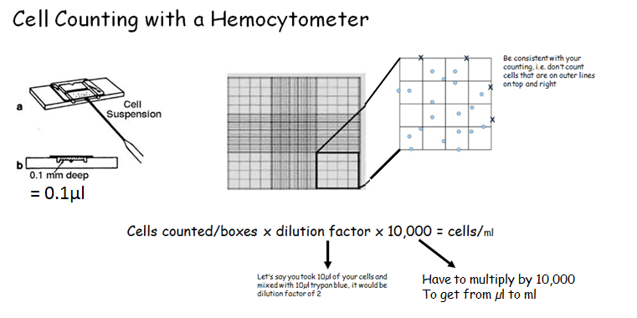

Establishing a Primary Cell Line Using Chick Embryos
- Isolation of the embryos
  - Materials:
    - DBSS with high concentration of antibiotics
    - Small beaker or egg cup to hold egg
    - Forceps (sterilized), beaker of alcohol to dip them in
    - Sterile petri dishes
    - Eggs, 10th day of incubation, humid incubator to incubate the eggs
    - Dissection tray (that has been sterilized)
  - Procedure:
    - Incubate the eggs at 38.5C, turn daily
    - Swab the egg with alcohol and place in egg cup
    - Crack the top of the egg and peel off the shell to the top of the air sac with forceps
    - Using another pair of sterile forceps, peel off the shell membrane to reveal the chorioallantoic membrane
    - Gently pour contents into sterile dish
- Chick embryo organ rudiments
  - Materials:
    - Dissecting scope
    - DBSS
    - Media
    - Trypsin
    - Petri dishes
    - Sterile scalpels
    - Sterile forceps
    - Pipettes
    - 50ml centrifuge tubes
  - Procedure:
    - There are a couple of ways to do this. Choose what organ/tissue you would like to dissect out
    - Extract that organ or tissue using scalpel and forceps
    - Place in tube the organ or tissue with cold trypsin for 6 h (we skip this step)
    - Place in new tube with warm trypsin and incubate for 20min at 37C
    - Carefully discard trypsin
    - Pipette media up and down to disperse the tissue, allow large pieces to settle to bottom
    - Transfer cell solution to petri dish or flask and incubate
    - Change medium as required and observe for growth

