General Biology I Laboratory
Supplemental Packet
Indian River State College

Fall 2013

GENERAL LABORATORY RULES

1. During the first week of class your instructor will provide you with a schedule
of laboratory exercises. Your preparation is critical. You are expected to be familiar with
the content of each exercise when you arrive in the lab. Read the lab exercise PRIOR to
the laboratory meeting time. Study basic biological concepts dealing with the lab activity
from the lab manual and the lecture text. Laboratory content will not be directly addressed in lectures.

2. BE ON TIME. The laboratory instructor will give verbal instructions at the beginning of each laboratory. Anticipated difficulties will be pointed out, special group assignments will be made, and changes in procedure will be noted. Take careful notes on these instructions. There is not time to repeat these instructions for each person/group.

3. A clean work area is a safe work area. Cleanse the tabletop with ethanol prior to the beginning of each exercise and at the close of your lab. Tabletops should remain clean and uncluttered at all times. Books, bags, purses and extraneous supplies should be located under the student workstation and away from the work surface and traffic areas such around the sinks. Marks on the lab tables are best cleaned with a small dab of cleanser and rubbing with a green pad (located in each student drawer). Prevent marks by laying the plastic sheet from your storage cabinet or placing a paper towel under your microscope, metal-edged notebooks, purses, or book bags.

4. No smoking, eating, or drinking is allowed in the confines of the laboratory, and it is wise to keep your hands away from your face. Long hair should be tied back, as a safety precaution.

5. Remain serious-minded and methodical to help you to complete assignments on time and to organize your own material for study. Remember to work independently, but cooperatively with your laboratory partners and with other groups. Lab group assignments are considered permanent for the semester and your table and microscope assignments will be made during the first lab.

6. Before leaving class on the first meeting be sure to familiarize yourself with the
location of the first aid equipment, fire safety equipment and emergency evacuation
procedures. Remember to use all equipment and supplies according to directions. Wear
protective gear when it is required. (The lab will supply gloves only when dealing with
human body fluids. You will need to supply protective eye wear, lab coats, and gloves if you choose to use these during dissections.) Always properly clean and store all equipment at the end of class, and wash your hands thoroughly when entering and leaving the laboratory. IMMEDIATELY report any injury to your instructor.
Contact IRSC Security:
Main Campus 772-462-4755, x 7777
Chastain Campus 772-519-2623, x5666
Mueller Campus 772-519-2622, x2531
Dixon Hendry 772-528-9322
Pruitt 772-336-6248

7. While running experiments, never leave your work station unattended.

8. Each laboratory exercise format is to a great extent self-explanatory. Before you
begin:
a. Read your lab assignment outlined on the lab syllabus BEFORE coming to
lab.
b. Review your conceptual goals. Prepare flow charts for activities, time required,
etc.
c. Listen to your instructions given by your lab instructor. Take notes.
d. Organize responsibilities among members of your lab group.
e. Assemble materials required for the activity (from student station or lab
counter).
f. Review the entire activity prior to beginning the actual lab work.
g. Note safety tips, boxed hints or landmarks.
h. In dissection activities, cut and remove very little. Expose organs in
relationship to one another. Consult lab manual diagrams frequently.
i. For microscopic study, make drawings carefully and label significant structures.
j. Always treat all equipment carefully to guard against breakage or damage.
Return all prepared materials to their appropriate locations before the next class.
k. No materials leave the laboratory setting. No animals used for dissection are
allowed out of the lab. The lab is responsible for the proper disposal of these animals. Other lab supplies are required for use by multiple lab sections and cannot be removed from the laboratory. (Check the Academic Support Center (ASC) on Main Campus above the Library for study models, skeleton, microscopes and slides)
l. Complete your laboratory report carefully before moving to the next exercise.

9. What do I do if I missed my lab? You will need to attend another regularly scheduled lab during the activity week as presented on your syllabus. Check with the instructor to make sure that there will be space available for you. There is an attendance form that you must sign and give to the “make-up” lab instructor so that your regular lab instructor will be notified that you attended a lab for that activity.

10. What do I do if I missed my lab practical? There will be NO makeup practicals given. Students are to take the scheduled practical during their scheduled lab. Students missing the final practical and who are passing the course will be given an “Incomplete”. Otherwise, the final practical will be counted as a ZERO twice. Check your lab syllabus for further instructions about a missed practical. Being late on practical day will mean that you miss your lab practical. Practicals are timed tests and one started, no admissions to the practical are allowed.

11. What do I do if I need more time to study the lab materials?
A. Use the ASCs.There you will find some models, charts, microscopes and slides that may
help you study for lab practicals (not all materials available in every ASC lab). Check the days/times for biology staff tutors at the ASC, if applicable.
B. Open lab time. Labs on Main Campus are open for extra study between
8:00a.m. to 5:00 p.m. on Monday through Thursday (excluding
Holidays) when there is no scheduled lab in the room. Biology faculty or
the Biology Lab Manager will let you into the lab. Students will sign in and
out using the log sheet located on the front desk. Students must leave the
lab at least 30 minutes before the next lab session is to begin. Students
may not provide access to another student. **The lab room is not available once the lab practical is set up in that room. ******Don’t wait till the last minute. ***** ++No new dissection can take place in open lab unless the entire dissection group is present.
C. Attend other scheduled labs. You may request permission to attend another
lab section of your lab course, provided there is space available. Be
courteous. Arrive before class to make your request. Do not interrupt the lab instructor once his/her presentation has started. Be aware that the instructor’s priority is to the students registered in that lab and the instructor has the right to refuse you.

12. The IRSC Biology Departmental web site is helpful to find schedule of labs for each biology course, your lab syllabus, photos of cell division slides, etc. Enter the following web address —http://biology.irsc.edu/dept/biologicalsciences/default.htm
Select “Lab Resources” for your lab course. Check for answers to your biology and microbiology lab manual questions.

BIOHAZARDOUS WASTE DISPOSAL:
A. Sharps container (red box above biohazard bin) is for human blood or
pathogen contaminated toothpicks, capillary tubes, lancets. Non-contaminated gloves or paper towels go in regular trash bins.
***Please note the special broken glass bin location in the lab. This is for any broken glass that is not contaminated with human blood or pathogens. Please alert your lab instructor of breakage so that necessary replacements to lab supplies can be arranged.
B. Large pieces of animal tissues and the remains of animals following dissection
are placed in the biohazard bin (or biohazard container indicated by your instructor) for cremation. Because we respect life, these materials are not haphazardly discarded in general trash. ***Gloves or paper towels which have touched dissections are not considered biohazardous and are discarded in the general trash bin. *Gloves and paper towels contaminated with human blood are considered biohazardous and are to be placed in the large, red plastic-lined biohazard bin.

REMEMBER: Use of equipment in the lab is a privilege.
You are responsible for care and correct usage of these facilities and equipment.
Labs are monitored and any misuse of the facilities and its equipment will be noted.
Any irresponsible attitudes or practices MUST be corrected or the laboratory use privileges will be denied to you in subsequent labs. This is an appropriate setting to nurture your professional attitudes and behaviors which will put you in good standing in your future career pursuit.

THE MICROSCOPE
Parts of the binocular compound microscope
- Identify parts, know their functions:
  - Ocular, diopter adjustment, ocular micrometer, pointer, body tube or head, revolving nose piece, objectives (scanning, low-power, high-power, oil immersion), arm, coarse adjustment knob, fine adjustment knob, base, light source, iris diaphragm, iris diaphragm lever, condenser, condenser height control knob, pull-out phase adapter, stage, graduated mechanical stage controls, power switch, electrical cord, plug.

Computation of total magnification of specimen being viewed:
- Magnification = ocular x objective (ocular on this scope is 10X)
- Scanning (red band) 4X x 10X = 40X
- Low-power (yellow band) 10X x 10X = 100X
- High-power (blue band) 40X x 10X = 400X
- Oil immersion (white band) 100X x 10X = 1000X

Care and handling of microscope:
Report any problems with your microscope to your instructor IMMEDIATELY.
1. Locate your microscope by number in the cabinet. Carry with two hands, one under base and other around the arm. Keep the microscope near your body.
2. Place scope gently on the lab table on top of plastic sheet.
3. Do not disassemble your microscope or reorient the oculars.
4. Keep the scope and lens systems clean.
- Clean lens with lens paper (in drawer)
- Clean stage and slides with Kim wipes (on lab bench)

Storage of your microscope: This is the way microscopes are to be stored in the cabinet.
- Scanning objective (4X with red band) in position!
- Power switch off.
- No slide left on the stage.
- All lenses and the stage must be clean.
- Graduated mechanical stage centered.
- Stage in the full down position. (Do not lower the condenser.)
- Cord wrapped around the cord holder.
- Plastic dust cover is on.
- The microscope sets above its number on the cabinet shelf.

Focusing the Microscope:
- Clean slide to be viewed. Wipe gently with a Kimwipe. If oily, place a few drops of 70% ethyl alcohol onto the Kimwipe and gently wipe the cover slip and bottomof slide. Never place alcohol directly onto a prepared slide.
- Place the slide down on the front of the stage with the label facing up and in position to be read, use stage clip to hold slide in position
- Turn on the light to sufficient intensity to produce a WHITE background (not yellowish). Note that the condenser is in the full up position. Locate the condenser height control knob forward from course / fine adjustment knobs.
- Use the course adjustment knob to bring the slide into focus.
- Use the iris diaphragm lever to adjust the amount of light striking your specimen. More light will be needed for preserved and stained slides and at higher magnifications. Less light is required for thin preparations and unstained slides. Remember the condenser remains in its full uppermost position.
Moving to next higher magnification power
- Center the specimen to be examined further in the CENTER of the field of view. These microscopes are parfocal. This means that the specimen is focus at the center of the field of view will be in partial focus as the next power.
- Grasp the revolving nosepiece and rotate it to the next power lens (low power – yellow band).
- Only minor adjustment with the coarse adjustment (for scanning and low-power objectives ONLY), then fine adjustment (no more that 2 revolutions) if needed.
Again center the specimen being viewed and rotate nosepiece to next power (high power – blue band). Focus using ONLY fine adjustment.
- To use the 100X objective, you need to add a drop of immersion oil on the slide.
After observations have been completed:
- Move the revolving nosepiece to low and then to scanning. Do not drag the oil immersion objective (longest objective) across the cover slip – scratching it !
- Open the spring stage clip and slide the microscope slide out to the forward edge of the stage.
- Return the clean slide to where you obtained it (your slide box or the side counter).
- Do not lower the stage or turn off the light if you have another slide to view.
- View other slides that are assigned.
- After last slide of the day is finished, prepare the microscope for storage as outlined
Oil immersion techniques: (used to visualize bacteria)
- Focus the slide as before under the scanning, low power, and high power objectives. Now the stage and lighting are set for the best resolution of the specimen.
- DO NOT lower stage!
- Rotate the revolving nosepiece back the way you came to high (back to low, then to scanning). Do not drag the long oil immersion objective over the cover slip.
- Place a drop of immersion oil (from your drawer) on the cover slip where the light is passing through the slide. Be careful not to allow any oil to flow over the edge of the slide onto the condenser lens or onto the stage.
- Looking from the side of your scope, visually confirm that the objective will not touch the cover slip of the slide. Rotate the revolving nosepiece DIRECTLY from Scanning (4X) objective to the 100X objective. You can see the oil come into contact with the 100X objective.
- Focus using the fine adjustment knob.
- You may need more light. Move the iris diaphragm lever to allow more light on the slide.
- After study of specimen is complete, turn the revolving nosepiece DIRECTLY from 100X objective to the 4X objective. This avoids bringing other long lenses in contact with the oil.
- Open the spring stage clip and remove slide forward toward the edge of the stage.
- CLEAN the slide – Remove most of the oil by blotting cover slip with a Kimwipe, add some 70% ethyl alcohol on a clean Kimwipe and remove any remaining oily residue. Return clean slide to where you obtained it (your slide box or side counter)
- CLEAN the 100X objective if you are through using oil for this lab session. Blot (do NOT rub) the objective with a clean Kimwipe. Use lens paper to polish the 100X lens until no oily residue is observed on the Kimwipe. Use lens paper to check other objectives to be sure no oil is on them.
***Never use any liquid to clean you microscope lenses.***
Using phase contrast optics:
This type of microscopy is used when live, unstained specimens are to be viewed. (Micro Lab)
- Focus the specimen as you have been instructed above on 4X, 10X, and 40X.
- When you are in best focus on high power (40X objective), push the phase ring holder (under stage) into the path of light. Make sure the condenser is raised to its highest position. Also, make sure the lever controlling the amount of light entering the condenser is fully open. You may also have to turn the light source on full.
- Only the high power (40X) objective may be used with the phase contrast optics.

Using dark field optics:
This type of microscopy is used when studying diatoms and algae. (Micro Lab)
- Obtain a dark field adapter. Your lab instructor who will show you where to obtain the adapter numbered for your microscope.
- Remove the blue filter and snap it onto the bottom of the adapter.
- Snap the top of the adapter to the bottom of the condenser.
- Focus normally. Your best resolution will be at low power. Note the different colors.

Measurement of a specimen using the microscope:
Use the ocular micrometer – the small “ruler” in the right eyepiece.
For small specimens which will fit under the ocular micrometer:
- Position ocular micrometer over specimen. Move the slide on stage to position the specimen. You can move the ocular micrometer by rotating the ocular. The size of the specimen can be determined by multiplying the number of ocular micrometer spaces covered by the specimen by the conversion factor for that objective as given in the following:
  - OBJECTIVE OCULAR MICROMETER CONVERSION FACTOR
- Scanning 25 microns (micrometers)
- Low-power 10 microns
- High-power 2.5 microns
- Oil immersion 1.0 microns

Animal Cell Diagram

Plant Cell Diagram

MEASURING THE RATE OF OSMOSIS

In this experiment, dialysis tubing will be used that will represent differential permeable membranes – water can pass through but sugar cannot.
Each group of students will use five dialysis bags. Each bag should be tied at one end by folding the end over and tying with a string. Make sure it is leak-proof.
Carefully insert a small funnel into the top of the bag to fill with following:
- Bag 1: 15 ml of tap water
- Bag 2: 15 ml of 20% sucrose solution
- Bag 3: 15 ml of 40% sucrose solution
- Bag 4: 15 ml of 60% sucrose solution
- Bag 5: 15 ml of tap water
As each bag is filled, remove the air by gently squeezing the bottom end of the bag to bring the liquid to the top of it. Press the sides of the bag together so that air does not reenter. Fold the end of the bag over about 2 inches (5 cm), and tie securely with a string. Weigh each bag separately to the nearest o.1 g, and record the weights in
the table at zero time.
Time  (minutes) | Weight of bag (g)
 | Bag 1 | Bag 2 | Bag 3 | Bag 4 | Bag 5
0
15
30
45
60

Place Bags 1, 2, 3, and 4 in separate 250 ml beakers of water and place Bag 5 into a 250 ml beaker of 60% sucrose solution.
At 15 minute intervals remove the bags from the beakers, carefully wipe off all excess water, and again weight each bag separately. Record the data in the table.
Place bags in beakers again until next 15 minute interval weigh-in.
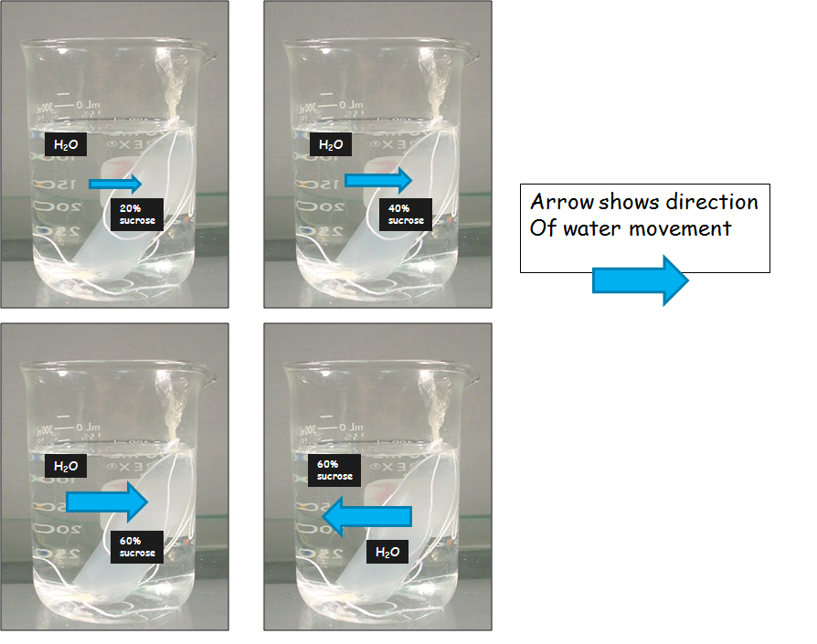
Plot the changes in weight of each bag against time. What relationship is there between the concentration of sucrose and the rate of osmosis? Explain.

CLEAN UP: Remove string from one end of bag without cutting the bag. Empty contents of bags, rinse bags with tap water, and return used bags to designated container. Wash glassware with soap and water. Final rinse is with alcohol for quick dry of containers too small to dry with paper towels (graduated cylinders, droppers, funnel neck).

MATERIALS NEEDED PER GROUP:

5 250 ml beakers
50 ml graduated cylinder
Small funnel
5 soaked dialysis (8 inch strips)
string to tie 5 bags at both ends
scissors to cut string for ties
1 triple beam balance
15 ml of 20% sucrose
15 ml of 40% sucrose
15 ml of 60% sucrose for bag 4
180 ml of 60% sucrose - beaker 5
Grease marker to label beakers
Tap water for bag 1
Tap water for beakers 1, 2, 3, & 4

CELLULAR RESPIRATION
- Construct respirometers:
  - Obtain 3 vials, each with an attached stopper and calibrated pipette.
  - There is cotton in the bottom of each vial – saturated with 15% potassium hydroxide (KOH), absorbs CO₂. Caution – KOH is caustic!
  - Vial 1
    - Obtain a 100 ml graduated cylinder and add 50 ml of water, drop in 25 germinating peas, and measure the amount of water displaced (that is, how much the water rises above 50 ml). Record this number here: ____ ml. Remove the water and germinating peas. Dry the peas on a paper towel.
    - Place 25 peas in Vial 1
    - Insert stopper with attached pipette.
  - Vial 2
    - Again add 50 ml of water to the 100 ml graduated cylinder and this time drop in 25 non-germinating peas (smaller than germinating). Add glass beads until the same amount of water is displaced as in step 3. Remove the water and glass beads. Dry the glass beads and peas on a paper towel.
    - Place peas AND glass beads in Vial 2
    - Insert stopper with attached pipette.
  - Vial 3
    - Once more, add 50 mil of water to the 100 ml graduated cylinder. Then, drop in glass beads until the same amount of water is displaced as in step 3. Remove the water and glass beads. Dry the beads on a paper towel.
    - Place glass beads in Vial 3
    - Insert stopper with attached pipette.
- Lay the 3 respirometers in water bath, with the pipette tips resting on the test tube rack (out of water).
  - Wait 7 minutes so that the temperature of the vials and.the water bath is the
  - Then shift the respirometers on the rack so that the pipette tips are completely submerged in water.
    - Water will enter the pipettes for a short distance and then stop. Record this initial position of the water drop to the nearest 0.01 ml on the table below.
    - If water continues to move into a pipette, check for leaks in the respirometer. Quickly arrange the pipettes so that they can be read through the water at the beginning of the experiment. Keep your hands out of the water bath after the experiment has started.
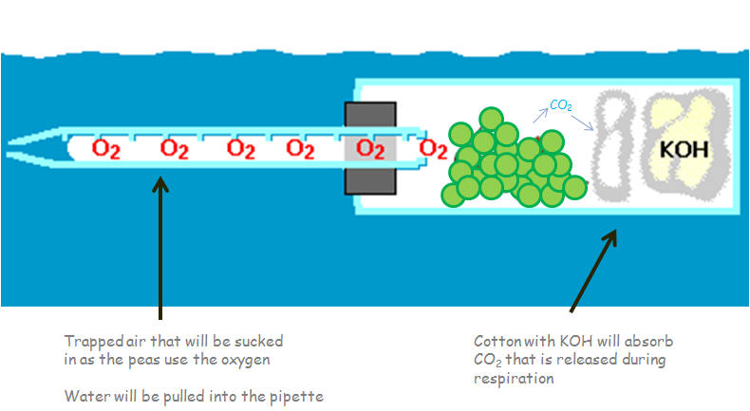
- Complete the table of data:
  - Wait 10 minutes, and then record in the data table any change in the position of the marker drop.
  - Wait 10 minutes (20 minutes after start), and then record in the data table any change in the position of the marker drop.
  - Then record the net change of each vial. Calculate by subtracting the vial's 20 minute reading from the initial reading for each vial.
  - Did the marker drop change in vial 3 (glass beads)? ____By how much? _____ Enter this number in the "Correction" column (CORRECT)and use this number to correct the net change you observed in vials 1 and 2(This is a correction for any change in volume due to atmospheric pressure changes or temperature changes).
Vial | Content | Initial Reading  A | After 10 minutes | After 20 minutes  B | Net Change  C | Correct  (Value C of Vial 3) D | Net change – correct  C - D
1 | Peas
2 | Peas + Beads
3 | Beads

FERMENTATION
- Mix 6 ml of suspended yeast solution with 12 ml of a sugar solution or water.
  - Resuspend yeast solution each time you add it to a tube.
  - Pour yeast mixture into a labeled fermentation tube for the test solution and invert once to fill the calibrated portion of the tube.
  - 4 fermentation tubes:
    - Yeast + Glucose
    - Yeast + Sucrose
    - Yeast + Fructose
    - Yeast + water
- Carefully carry the fermentation tube to the water bath. Place the fermentation tube in a 38°C temperature water bath.
  - Allow the tubes to incubate; stop the incubation when appropriate (3 -4 ml of CO₂ bubbles).
  - At the end of the incubation period, measure the final volume of CO₂
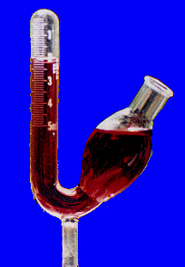

CHI- SQUARE CORN DATA SHEET and WORKSHEET

General Biology I Lab
Genetics Problems

- How many different gametes would you expect from a man who is homozygous for brown eyes, BB?

- What are the gametes of a person with genotype AABb? (Hint: there are 2, remember that in each gamete you need one of each letter)

- Give the number of expected types of gametes from the following genotype:
  - AaBbCC

  - DdEdFfGgHH

  - A person with all chromosomes in heterozygous pairs (hint: how many chromosomes do humans have?

    - # types = 2^{n} (n=number of heterozygous gene pairs in the example

- In fruit flies (Drosophila melanogaster), red eye color is dominant over white eyes. By crossing a heterozygous red-eyed male (Rr) with a heterozygous white-eyed female fly (Rr), 60 offspring result. How many would you expect to be red-eyed and how many white-eyed?
  - use a Punnett Square to answer this question

- In humans, albinism is controlled by a single recessive allele c, and normal pigmentation is controlled by dominant allele C.
  - What would be the phenotype of the following genotypes?
    - CC ________________
    - Cc ________________
    - Cc ________________
  - Suppose CC mates with cc, what would be the expected phenotypic ratio and genotypic ratio of the offspring? Do a punnett square

  - A man and woman plan to have children and wish to know the probability of their having any albino children. What would you tell them if they are both normally pigmented but each has one albino parent?

- In humans, earlobes can be attached or free. A man with attached earlobes marries a woman with free earlobes. All of their children have free earlobes. One son (free earlobes) marries, and of his many children, half have free earlobes and half have attached.
  - What is the phenotype of the man’s wife?

  - Is attached earlobes dominant or recessive?

- In dogs, wire hair is due to a dominant gene, smooth hair to its recessive allele. Two wire-haired dogs produce a male pup that has wire hair. To find out most quickly whether he carries the gene for smooth hair, he should be mated to what kind of female?

- Back to fruit flies – red eyes is dominant over white eyes.
  - Do a Punnett Square to show the cross of
    - RR x rr (P generation)

Offspring are F₁ generation

  - Now cross 2 F₁ to see genotypes F₂ generation

Offspring are F₂ generation

- In cattle, polled (P, hornless) condition is dominant over horned (p) and black (B) is dominant over yellow (b). What will be the genotype and phenotype of the F₁ in a cross between a homozygous polled homozygous black bull and a horned yellow cow? Do a Punnett Square

P generation : PPBB x ppbb

- A solid colored, short haired female rabbit (ssLL) is mated to a spotted, longhaired male (SSll). How many will be expected to be spotted with long hair? ___________ How many solid colored with short hair? ___________________

- In some dogs, barking (B) when trailing is due to a dominant allele, others do not bark (b). Also, erect ears (E) are dominant to drooping ears (e). What is the phenotypic ratio of offspring when you cross two heterozygous dogs (BbEe x BbEe)? Do a Punnett Square

 | BE |  | bE
Be
be

Barking, erect ears:_____barking, drooping ears:_____, no bark, erect ears:_____, no bark, drooping ears:_____

- Incomplete dominance: in snapdragons, red flower color (R) is incompletely dominant over white flowers (R’). The heterozygote RR’ will have pink flowers. Predict the results of a cross between a red-flowered snapdragon and a white-flowered one. Do a Punnett Square

- Sex Linkage: Normal vision in humans is dominant over color blindness and the gene is found on the X chromosome. A normal vision man (XY) has children with a female who is a carrier for color blindness (X^{c}X). What percentage chance is there that they will have a son who is colorblind?____ Do a Punnett Square

- Sex Linkage: A boy whose parents and grandparents had normal vision is color blind. Give the genotypes of his mother and maternal grandmother.

- In corn, purple kernels (P) is dominant over yellow (p) and smooth (S) kernels is dominant over recessive (s). Cross two heterozygotes PpSs x PpSs,
  - Do a dihybrid Punnett Square

  - Kernels have been counted on an ear of corn, the following data was collected:
    - Purple, smooth 195
    - Purple, wrinkled 71
    - yellow, smooth 80
    - yellow, wrinkled 25
  - Do these #’s follow the 9:3:3:1 ratio? Perform a Chi-square analysis:

Phenotype | Observed | Expected (e) | Difference (d) | d² | d²/e
Purple, smooth | 201 | 9 x 23.9 =
Purple, wrinkled | 77 | 3 x 23.9 =
Yellow, smooth | 80 | 3 x 23.9 =
Yellow, wrinkled | 25 | 1 x 23.9 =
 | Total 383 | Total 383 |  |  | X²=
383/16 = 23.9

After you get x², look at the Chi-square table in your book to see if the 9:3:3:1 hypothesis is supported or not supported. C-1 = 3 because we have 4 phenotypes in this example

COLOR BLINDNESS

KARYOTYPING
For the last 25 years karyotyping has been used to detect chromosome abnormalities in humans. The chromosomes are usually obtained from blood samples. Since the white blood cells contain large nuclei, these cells usually contain the best source of human chromosomes. Through a series of staining procedures, the cells with the largest visible
chromosomes are isolated, photographically enlarged, and then cut out and arranged into chromosome pairs. Highly trained scientists and doctors analyze the results to determine if there are any variations in the shape, length, or number of chromosomes. Over the years, this technique has been used to detect, and in some cases correct or treat, an increasing number of genetic diseases.

In this exercise, groups will receive chromosomes of a baby to karyotype and evaluate for traits such as eye color, hair color, blood type, genetic disease, and/or chromosomal abnormality.

Note that the gene for brown eyes (B) is not listed.
- While it is known that brown eyes are dominant over blue and green eyes, the locus of the gene for brown eyes has not been found. Due to this fact, in the following lab, when an indication of eye color is absent in the chromosomes, it can be assumed that the dominant brown eye gene is present. Additionally, if the indication of eye color is absent in one parent, but present in the other, the dominant trait of brown eyes will take precedence.
The gene for brown hair (B) is also dominant over the gene for red
- (R) hair. Red or blond hair is only expressed when brown hair is not coded on Chromosome #19.
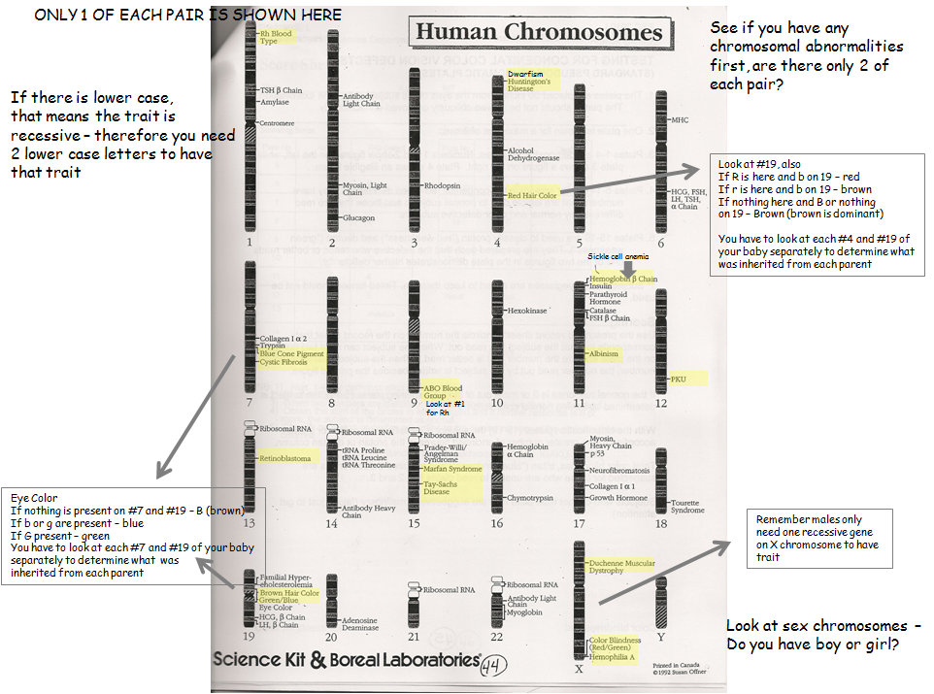

KEY TO GENE SYMBOLS FOR KARYOTYPING
Chromosome # | Gene | Symbol
9 | Blood Type A | IA
9 | Blood Type B | IB
9 | Blood Type O | IO (recessive to A and B)
1 | Rh+ Rhesus Factor | Rh+ (dominant over -)
1 | Rh- Rhesus Facto | Rh -
4 | Blond hair | r or b (check #19)
4 | Red hair | R (check #19)
19 | Brown hair | B (dominant over R, r, and b)
7 | Blue eyes | g or b (check #19)
19 | Green eyes | G
? | Brown eyes | B (dominant over blue and green)
4 | Dwarfism | D
4 | Huntington’s Disease | H
7 | Cystic Fibrosis | c
11 | Albinism | a
11 | Sickle cell anemia | s
12 | Phenylketonuna (PKU) | p
13 | Retinoblastoma | R
15 | Tay-Sachs Disease | t
15 | Marfan Syndrome | M
X | Hemophilia | Xh
X | Color Blindness | Xc
X | Duchenne Muscular Dystrophy | XD

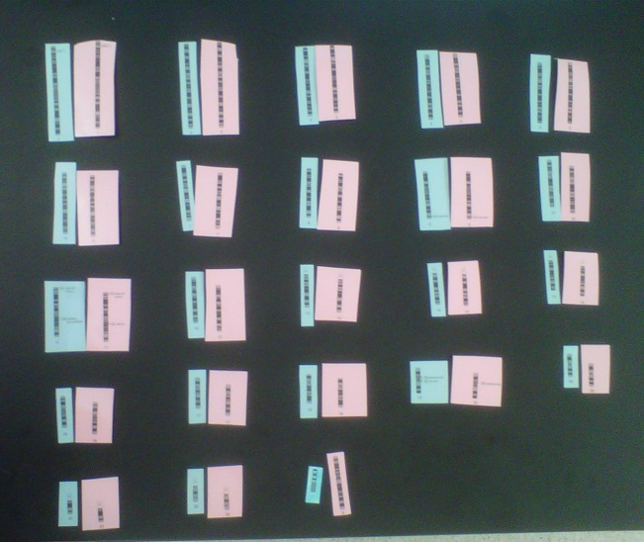 Karyotyping a baby (pink chromosomes came from mom, blue came from dad)

KARYOTYPING WORKSHEET

NATURAL SELECTION IN THE WILD:
COEVOLUTION OF PREDATOR AND PREY POPULATIONS

Adapted from: Fry, 1984, Exploring Biology in the Laboratory
2nd ed., Saunders College Publ., Philadelphia

Charles Darwin pointed out that some individuals produce more offspring than others, and that this difference is related to how well individuals are adapted to their environment. The best adapted individuals leave the most offspring – their genetic features are transferred to the next generation more frequently than are the features of less well adapted parents. The process is known as natural selection, and it causes changes in allele frequency from one generation to the next. A change in allele frequency in the population is evolution, and natural selection is the mechanism by which evolution takes place.

In this laboratory exercise you will simulate the effects of natural selection on two populations – a predator and its prey. At the beginning of the simulation each population will have a variety of phenotypes. As you simulate natural selection over three generations in the lives of these populations, you will see how natural selection results in the survival and reproduction of particular phenotypes of predators and prey (differential reproduction), and you will see the allele frequencies in the populations change over time (the populations evolve). You will be able to make inferences about physical characteristics of individuals in these populations which helped them survive and reproduce. These physical characteristics are known as adaptations.

HOW TO

Our simulation will consist of a game in which predators (students) with different size mouths (forceps) will compete to capture prey (beans) which vary in color. We will begin with four predator phenotypes (tiny, small, medium, large) and four prey phenotypes (black, brown, tan, white). To begin generation one, three predators of each phenotype will compete for 100 prey of each phenotype in an arena of about 16 m². The arena will be set up outside on the lawn. Predators will pick up beans with their forceps and place them in their stomach (a small glass dish). In order for the predators to compete on an equal basis, all forceps must be held with the end of the forceps pressed against the palm of the hand ( your TA will demonstrate). Each feeding bout will last 2 min. The allele frequency of each phenotype = (number of individuals with a particular phenotype)/(total number of individuals).

After each feeding bout the predators will count the number of beans eaten of each phenotype and your TA will record these on the board. Record these data on your own data sheet. The six most successful predators will survive and reproduce one offspring and the other six will die and leave the game. Six new student predators will be chosen for generation two.

The calculation of survival and reproduction in the prey population is described here and on the data sheets. First calculate the number of each phenotype eaten by adding the number eaten by each predator. Next calculate the number of each phenotype which survived by subtracting the number eaten from the initial number of each phenotype (e.g., 100 for round 1). In order to keep the number of prey available in each round at about 400, we will have each prey phenotype reproduce in proportion to its survival (that eaten least survives best and reproduces best). Calculate the proportion of surviving prey which belong to each phenotype: (proportion surviving = (number surviving/(total survivors). Next calculate the number of progeny of each phenotype: number of progeny = (proportion surviving) x (total eaten). Finally, count out the number of progeny beans of each phenotype and give them to your TA so they can be added randomly to the surviving prey in the predation arena. The number of prey at the beginning of generation 2 is equal to the number of survivors plus progeny of each phenotype. Record these numbers on data sheet 2 and begin the second generation of predation.

Repeat the calculations following generation 2 and generation 3. You have now simulated the survival and reproduction of three generations of a predator population and its prey population. Calculate the final allele frequencies of the predator and prey phenotypes: (number of individuals with a particular phenotype)/(total number of individuals). To complete this exercise, graph the initial and final allele frequencies for each predator and prey phenotype and answer the following questions.

DATA FORM
GENERATION #1

SIZE OF PREY POPULATION BEFORE PREDATION

Black | Brown | Tan | White |  | Total

NUMBER OF PREY EATEN
PREDATOR
TYPE
 |  |  | Black | Brown | Tan | White |  | Total | Rank
1
2
3
4
5
6
7
8
9
10
11
12
No. | Eaten |  |  |  |  |  |  |  | Total
No. | Surviving |  |  |  |  |  |  |  | Total
Proportion
Surviving
No. | Progeny

No. Surviving = (Population Size Before Predation) – (No. Captured)
Proportion surviving = (No. Surviving) / (Total Survivors)
No. Progeny = (Proportion Surviving) x (Total Captured)

DATA FORM
GENERATION #2
SIZE OF PREY POPULATION BEFORE PREDATION

Black | Brown | Tan | White |  | Total

NUMBER OF PREY EATEN
PREDATOR
TYPE
 |  |  | Black | Brown | Tan | White |  | Total | Rank
1
2
3
4
5
6
7
8
9
10
11
12
No. | Eaten |  |  |  |  |  |  |  | Total
No. | Surviving |  |  |  |  |  |  |  | Total
Proportion
Surviving
No. | Progeny

No. Surviving = (Population Size Before Predation) – (No. Captured)
Proportion surviving = (No. Surviving) / (Total Survivors)
No. Progeny = (Proportion Surviving) x (Total Captured)

DATA FORM
GENERATION #3

SIZE OF PREY POPULATION BEFORE PREDATION

Black | Brown | Tan | White |  | Total

NUMBER OF PREY EATEN
PREDATOR
TYPE
 |  |  | Black | Brown | Tan | White |  | Total | Rank
1
2
3
4
5
6
7
8
9
10
11
12
No. | Eaten |  |  |  |  |  |  |  | Total
No. | Surviving |  |  |  |  |  |  |  | Total
Proportion
Surviving
No. | Progeny

No. Surviving = (Population Size Before Predation) – (No. Captured)
Proportion surviving = (No. Surviving) / (Total Survivors)
No. Progeny = (Proportion Surviving) x (Total Captured)
LABORATORY REPORT

- Which prey phenotype appeared to be best adapted to local conditions of vegetation cover and predation pressure?

- Why?

- Which prey phenotype appeared to be least adapted to local conditions of vegetation cover and predation pressure?

- Why?

- Which predator phenotype was apparently best adapted for feeding on prey or this particular size?

- Did any predator genotype become extinct, i.e., were one or more of the alleles controlling the size of prey capturing structures lost from the gene pool?

- I f not, can you predict which predator genotype is most likely to become extinct?

- Why?

- Describe, in terms of adaptation and natural selection, how evolution may occur in a natural population.

- Use the following diagram to construct histograms (bar charts) to compare the original genotype frequencies of the predator and prey species to those frequencies at the end of the demonstration.

Predator Allele Frequency:

 | Initial |  |  | Final
100 |  |  | 100
75 |  |  | 75
50 |  |  | 50
25 |  |  | 25
0 |  |  | 0
Tiny Small Medium Large |  |  | Tiny Small Medium Large
PHENOTYPE PHENOTYPE

Predator Allele Frequency:

 | Initial |  |  | Final
100 |  |  | 100
75 |  |  | 75
50 |  |  | 50
25 |  |  | 25
0 |  |  | 0
Black Brown Tan White |  |  | Black Brown Tan White
PHENOTYPE PHENOTYPE

