CELL BIOLOGY AND PHYSIOLOGY LAB
Fluorescence Name:
Students must PRINT these worksheets and HANDWRITE your answers. Please keep all worksheets together in a binder.

- What is an emission filter? What is an excitation filter?

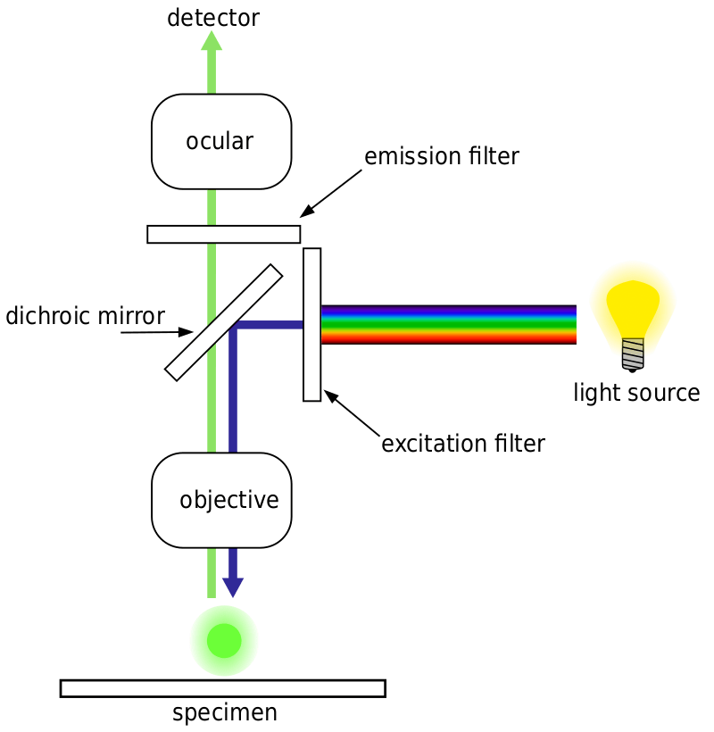

What are the steps to fluorescence microscopy?

- What is immunofluorescence?

- What is a fluorophore?

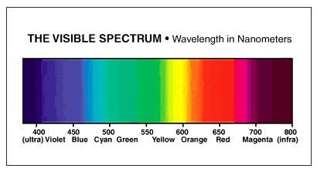

BioTracker 488 Green Mitochondria Dye
- Used to detect live cells, the dye accumulates in the mitochondrial membrane of live cells.
- Emission: 523nm
- Use GFP cube on Evos Microscope.
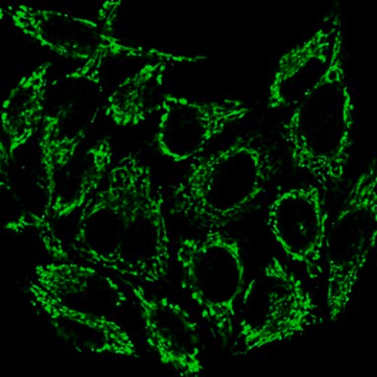

ER-Tracker Blue-White DPX
- Use to detect live cells, the dye is selective for the endoplasmic reticulum.
- Use DAPI cube on Evos Microscope.
- 1mM stock solution in DMSO.
- Warm the vial, then centrifuge to deposit DMSO at the bottom. Make the staining media:
  - Need 1µM solution – take 25µL and add to 25mL of fresh media.
- Remove old media from cells, add 5ml of staining media. Incubate at 37°C for 15-30 minutes.

NucBlue Live Cell Stain
- Binds to DNA.
- Add 2 drops per mL media, incubate 15-30 minutes. I have found it works best to do one drop per flask.
- Emission: 460nm max
- Use DAPI cube on Evos Microscope.

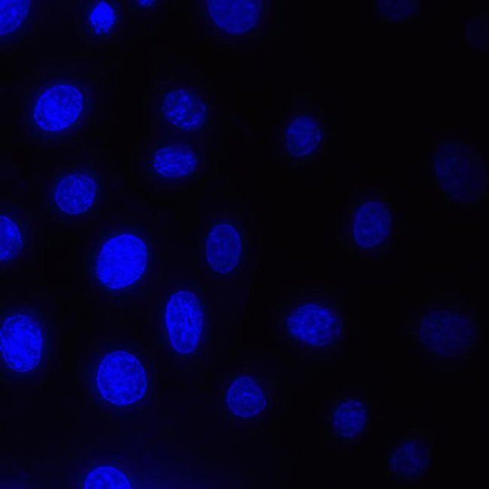

CellLight Tubulin GFP
- Binds to tubulin (microtubules).
- Add 75uL to flask, incubate overnight.
- CellLight® Tubulin-GFP, BacMam 2.0, is a fusion construct of human tubulin and emGFP, providing accurate and specific targeting to cellular tubulin-GFP. This fusion construct is packaged in the insect virus baculovirus, which does not replicate in human cells and is designated as safe to use with biosafety level (BSL) 1 in most laboratories. BacMam technology ensures that most mammalian cell types are transduced/transfected with high efficiency and minimal toxicity.

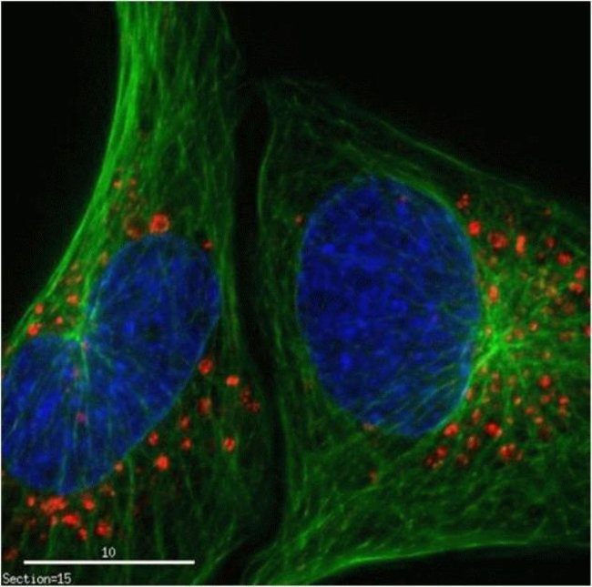 Notice the green microbutules.

MitoTracker Red CM
- Emission: 654nm
- Use Texas Red cube on Evos Microscope.
- Need to prepare 1mM stock solution in sterile DMSO.
  - Add 100.4uL of sterile DMSO to vial to make the 1mM stock solution
  - Now prepare media without serum. Need 1.0nM so you will need to do serial dilutions.
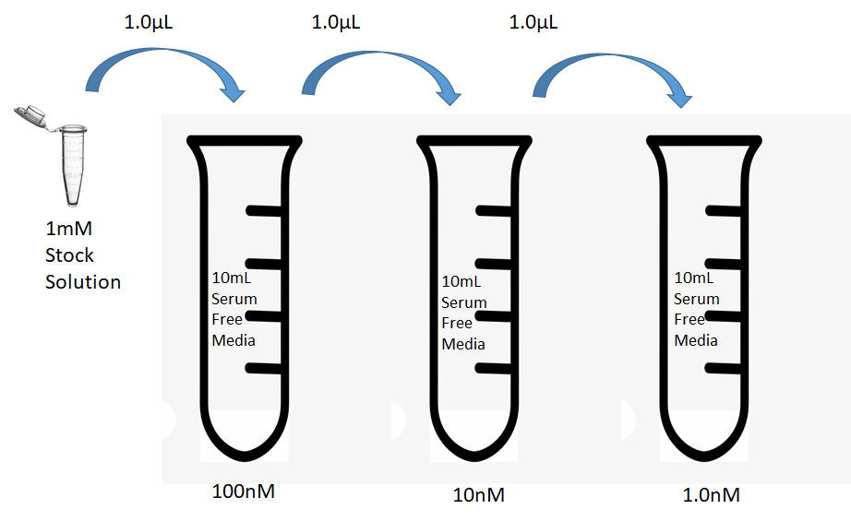

Mixing Fluorescent Dyes
- Incubate cells over night with CellLight Tubulin GFP
- Remove media
- Add media with MItoTracker Red
- Add 2 drops of NucBlue

