Cell Biology and Physiology Lab
Feeding Your Cells and Sub-culturing Name:

Mammalian cells should be fed every 2-3 days. Without changing the media, the cells will quickly die. Remember these cells are metabolically active, and are producing waste that must be eliminated. You will also notice a color change in the media as it gets “old.”

Feeding a monolayer culture in flasks
- Materials:
  - Media
  - Pipettes
  - Waste jar
- Procedure
  - Done under the hood! Make sure to prepare the hood properly
  - Warm media in warm water bath (spray with alcohol before placing bottle in hood)
  - Examine the culture first under the microscope to make sure it looks healthy
  - Take back to hood and loosen cap to flask (stand flask upright)
  - Pipette off old media and discard
  - Discard pipette
  - Using new sterile pipette, add new media to NEW flask (or other dish)
  - Return to CO2 incubator
Feeding a suspension culture
- These cells are not adhered to the flask or petri dish. Therefore, you must pipette your cell solution, place in 50ml centrifuge tube and centrifuge. Then bring the tube back to the hood, discard the old media, and then resuspend the cell pellet in new media

Subculturing (passaging, splitting) is the removal of the media and transfer of cells from previous culture dish to a new one in order to grow more cells. For adherent cells, this is done before they reach confluence. Certain cell types like certain seeding densities. Hela cells seeding density should be ~5 x 10⁵ cells/ml.

Subculture of monolayer cells
- Materials:
  - Media
  - Trypsin (0.25% in D-PBSA) – kept frozen
  - Sterile PBS
  - Pipettes
  - Waste jar
  - 50ml Centrifuge tubes
  - Centrifuge
  - Flasks (labeled)
- Procedure:
  - Done under the hood! Make sure to prepare the hood properly
  - Warm media and trypsin in warm water bath (spray with alcohol before placing under hood)
  - Discard old media
  - Add PBS (0.2ml/cm²) to flask to wash the cells
  - Discard PBS
  - Add trypsin (0.1ml/cm2) to the flask, make sure monolayer is barely covered
  - Place in incubator for 5 min
  - Remove flask from incubator, tap flask to dislodge the cells
    - Observe under microscope, if cells are not dislodged might have to incubate longer
  - Add media and pipette up and down
  - Pipette media (that now contains the cells) out of the flask and place in 50ml centrifuge tube
  - Centrifuge the cells (200rpm for 5 minutes)
  - Bring tube back to hood, discard media leaving cell pellet
  - Resuspend cell pellet in fresh media using a pipette (a fixed amount, say 2-5ml)
  - Count cells using hemocytometer (take 0.5ml of your cell solution and add 0.5ml trypan blue; refer to figure on how to determine cell count)
  - Dilute your cell solution depending on seeding concentrations of the cell line and dish you are using

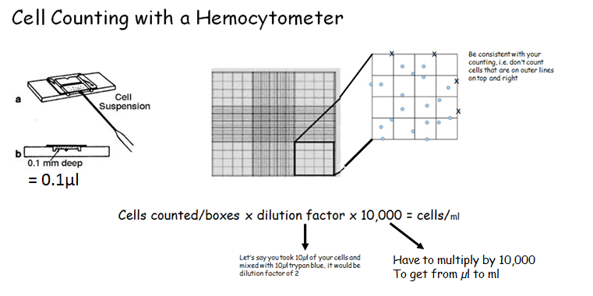
Let’s say you had 5ml sample. You took 50µl of sample and mixed with 50µl trypan blue and put on the hemocytometer. You counted a total of 250 cells in the 4 boxes (each corner of the hemocytometer).
250 cells total
4 boxes on the hemocytometer

250cells/4boxes x 2 x 10,000 = 1,250,000 cells/ml x 5ml = 6.2 x 10⁶ cells

If these are Hela cells and need to be seeded at 5 x 10⁵ cells/ml :
Questoins:

- How often should mammalian cells be fed?

- What causes the media to change color?

- With adherent cultures, you must use trypsin in the protocol for subculturing – what does the trypsin do?

- For the culture you worked with today:
  - You resuspended your pellet of cells in 5ml media
  - You then took 50µl of your culture and added 50µl of trypan blue and then counted on the hemocytometer
What was your total cell count for 4 boxes? _______

______cells/4 boxes x 2 x 10,000 = ___________ / 5 x 10⁵ x 5ml= _________ ml

