Dr. Capers’ General Biology I
Extra Credit Assignment

You can make either a DNA model OR a Cell Model – your model, if creative enough and well done, could be used in our display case in the N building

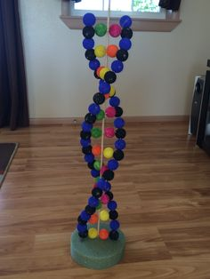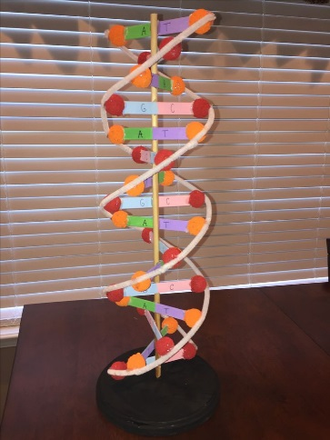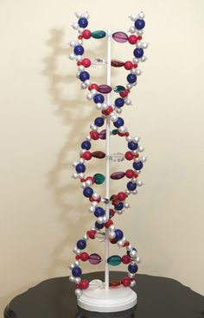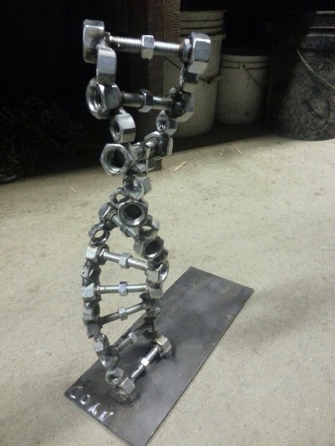

Parts that need to be labeled/identified: deoxyribose, phosphate group, Adenine, Cytosine, Thymine, Guanine

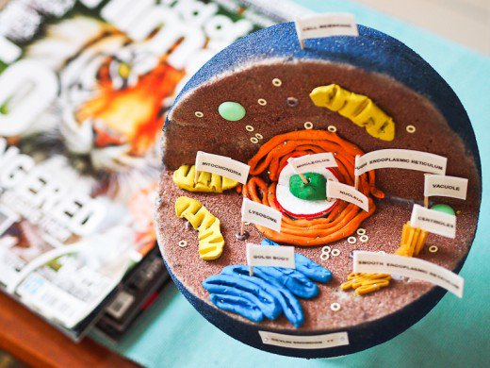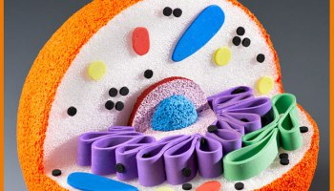

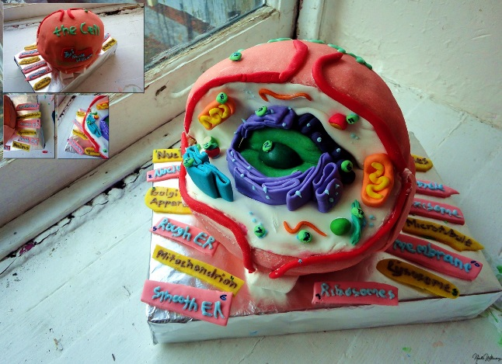 Parts that need to be labeled: nucleus, endoplasmic reticulum, golgi apparatus, mitochondria, cell membrane, ribosomes

