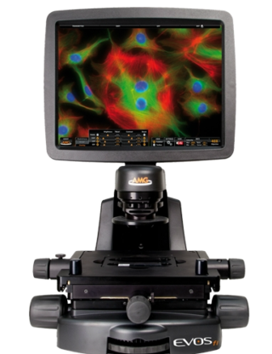EVOS LED Fluorescent Microscope

The EVOS LED Fluorescent microscope uses LED light cube technology that eliminates the need for a darkroom and use of toxic chemicals such as mercury arc lamps that are used with traditional fluorescent microscopes.
Fluorescence microscopy involves attaching fluorescent molecules to your sample (i.e. by way of labeled antibody specific for a particular cell structure) then exposing your sample to a specific wavelength (excitation wavelength) and visualizing the light it emits (emission wavelength) using the Fluorescent Microscope.
LED Light Cubes for the EVOS
CUBE | Excitation and Emission | Stain
Texas Red | 585 and 624 nm | Alexa Fluor 594, CellTracker Red, Live/Dead, LysoTracker Red, mCherry, SYTO 61, Texas Red
DAPI | 357 and 447 nm | Acridine, Alexa Fluor 350, DAPI, Hoechst, NucBlue, MarinaBlue, Pacific Blue
GFP | 470 and 510 nm | Alexa Fluor 488, Calcein, AM, CellLight GFP, CellTracker Green, CellRox Green, FITC, Fluo-4, GFP
RFP | 531 and 593 nm | Alexa Fluor 555, CellMask Orange, pHrodo, RFP, SYTOX Orange
CY5 | 628 and 692 nm | Alexa Fluor 647, CellMask Deep Red, CY 5, MitoTracker Deep Red, TO-PRO 3
CY7 | 710 and 775 nm | Alexa Fluor 750, DyLight 750

