Debunking Vaccine Myths

Why do we need vaccines? When you are exposed to a pathogen for the first time, your immune system mounts the PRIMARY immune response. One of 2 things will happen: either your immune system will be successful at fighting the pathogen OR you will die. If you survive, you now have memory B and T cells in your system (for a couple decades). When you come into contact with the pathogen again, the SECONDARY immune response will happen – it’s a much quicker response, either you won’t get sick or you may get sick but hopefully not as bad as the first time. Vaccines provide your body that PRIMARY immune response without having the actual disease. If enough of the population is vaccinated, it causes HERD immunity (therefore protecting the vulnerable and elderly).

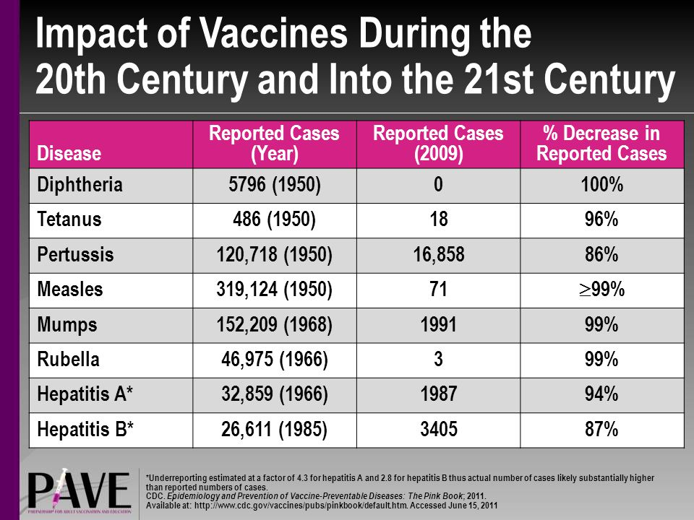
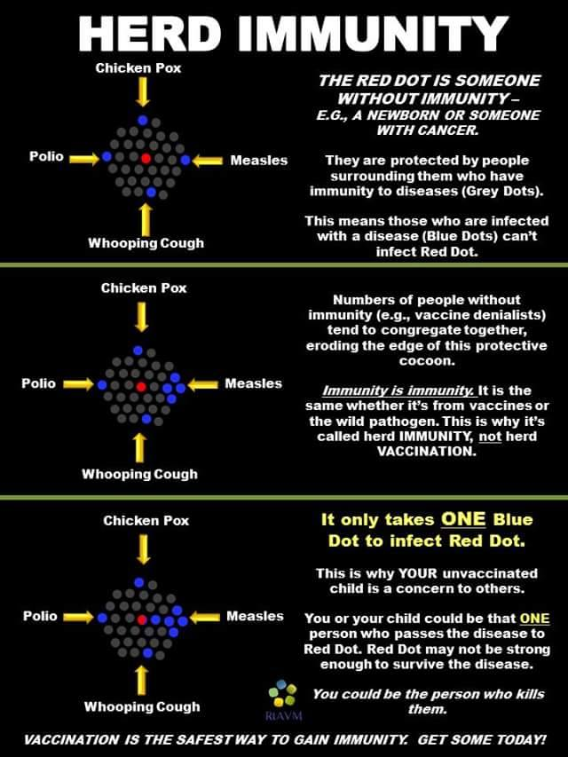
THESE ARE ALL MYTHS – NO PARTICULAR ORDER

Myth # 1 – You are pumping toxins into your child.
- There is no pumping, only small shots
- There is no elemental mercury in vaccines, never has been
- Ethylmercury (which is safely metabolized by the body) was removed from vaccines in 2001
- Other adjuvants like aluminum and polysorbate
  - Adjuvants increase the immune response, helping that vaccine work
  - Aluminum adjuvants are safe
  - Polysorbate – HPV vaccine contains 50 micrograms of polysorbate, while a small scoop of ice cream contains 170,000 micrograms…..so if you don’t believe in vaccines, you shouldn’t eat ice cream either
- Formaldehyde
  - Sounds scary, and yes in concentrated amounts can be deadly
  - But it’s also normal part of metabolism
  - Your body in a short time period produces more formaldehyde than is in the vaccines, your body can metabolize formaldehyde in micro amounts

Myth #2 – There are aborted fetus parts in the vaccines and injected into you.
- Fetuses are not ground up and put in vaccines. Babies are not aborted to produce vaccines.
- Here’s the truth:
  - Viruses can only grow in cells in which they infect. Therefore, to study viruses and make vaccines against them, you must have a cell line in which the virus will infect.
  - Some stem cell lines were derived from an aborted fetus (not the reason the fetus was aborted) to start growing to use. That was decades ago

Myth #3 – The cancer virus, SV40, is in vaccines.
- Some people in the 50s were exposed to SV40 virus that was in the polio vaccine. SV40 (which can cause tumors in some animals) was not discovered until 1960 so it was unknown. After it was discovered, it was removed. It has not been in any vaccine since 1963. Also, the people exposed to it should no increase of cancer.

Myth #4 – Vaccines cause autism.
- No, false, absolutely false
- Can’t say “CDC is corrupt” because studies done in other countries also prove that there is no link between vaccines and autism
  - Danish study of MMR and 537,000 children
  - Finnish study of MMR and 535,000 children
  - UK study of thimerosal and DPT/DT and 109,000 children
- Another myth: Dr. Wakefield was exonerated! First, it’s Mr. Wakefield (he lost his license). He was actually trying to tarnish the MMR to patent his own measles vaccine. He also paid kids at his kid’s birthday party to give him blood samples to study, without permission. He is a danger to society.

Myth #5 – My unvaccinated kid is not a threat to your vaccinated kid.
- Vaccines are not 100% effective (you may not be able to make the antibody, etc)
- Not all children can be vaccinated (those with allergies, chronic infections, etc)
- Some children are too young
- So yes, your unvaccinated kid is a threat to my vaccinated kid
- 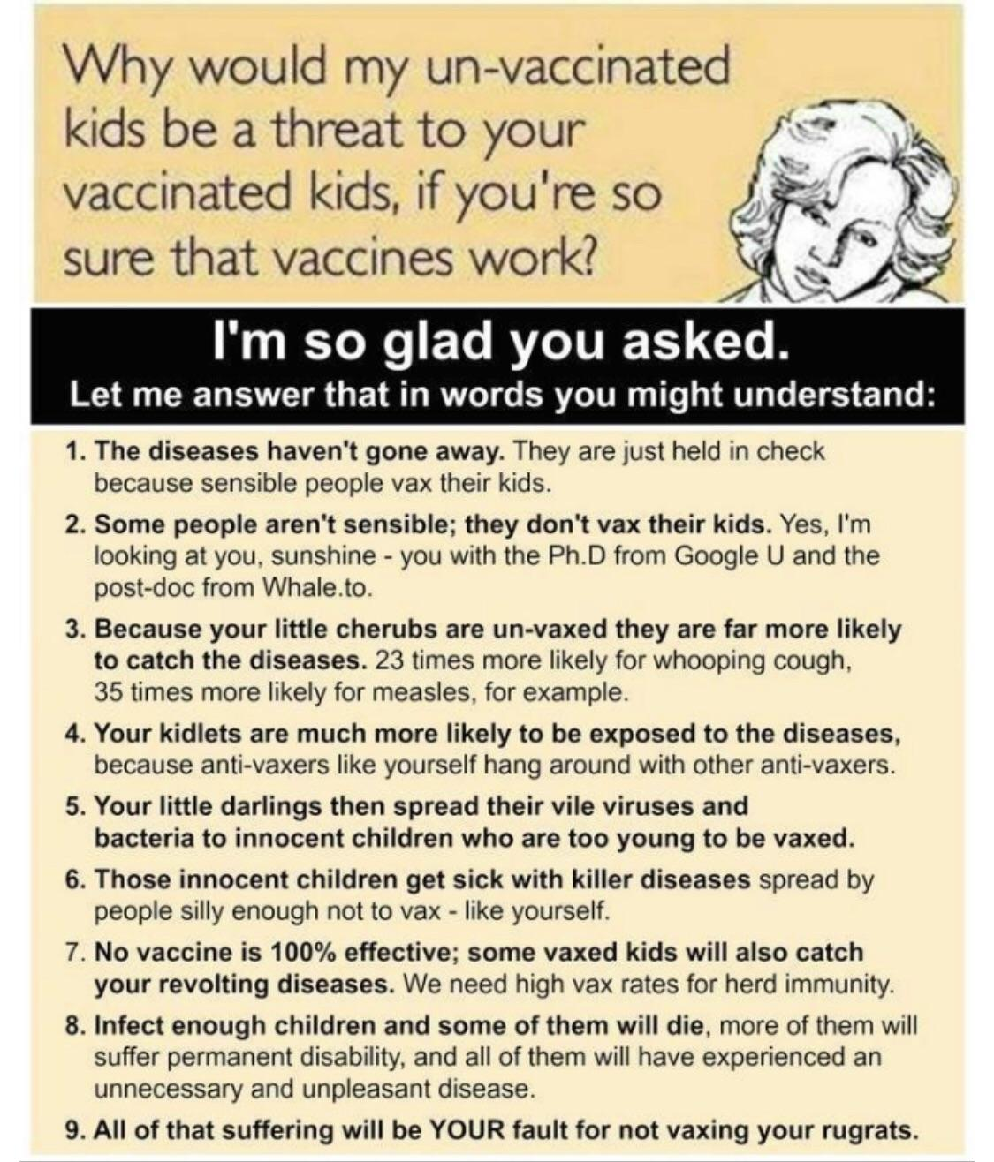

Myth #6 – These are just harmless childhood diseases.
- What harmless diseases kills over 100,000 of kids per year???
- Between 2000 and 2017, global measles vaccination increased from 72 to 85% while the measles rates decreased 83% and death rate fell 80%
- Chicken pox used to kill 100 kids in US alone
  - After vaccine introduced, number dropped to below 10 per year
- “I’ve never known anyone to have any of those diseases” – well, that’s nice but that’s due to vaccination and there are people in 3rd world countries still fighting some of these diseases.
- Have you gone to a graveyard and looked at tombstones from the late 1800s and early 1900s?

Myth # 7 – There are too many vaccines on the schedule.
- Anti-vaxers make argument that the amount of shots/vaccines is “unacceptable”……what is unacceptable? – the fact that modern science/medicine has discovered new vaccines to further prevent disease/death in our children?

Myth # 8 – There are too many vaccines too soon.
- So? Why is this a problem? Babies are exposed to thousands of antigens everytime they take that binky that just fell on the floor and put it in their mouth.
- A vaccine has something like 64 antigenic subunits, sticking your fingers in your mouth can expose your immune system to thousands (we are surrounded by foreign microbes! And our immune systems are capable of handling it….however, if your child gets very sick with one of these diseases, the immune system can become overloaded making them vulnerable to even more pathogens……)
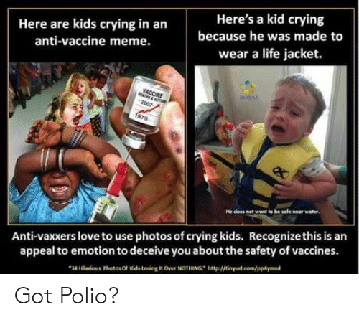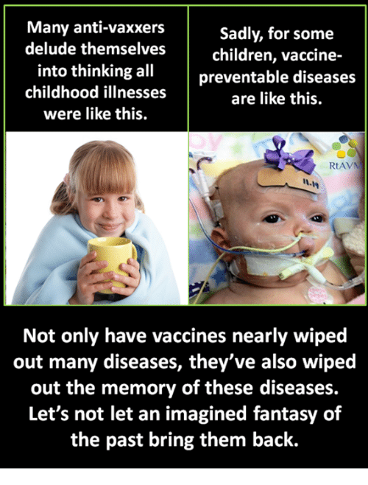
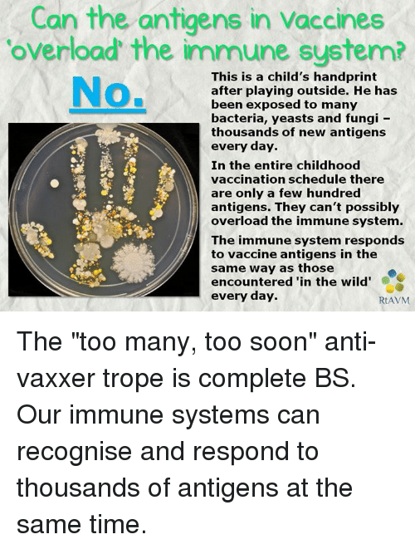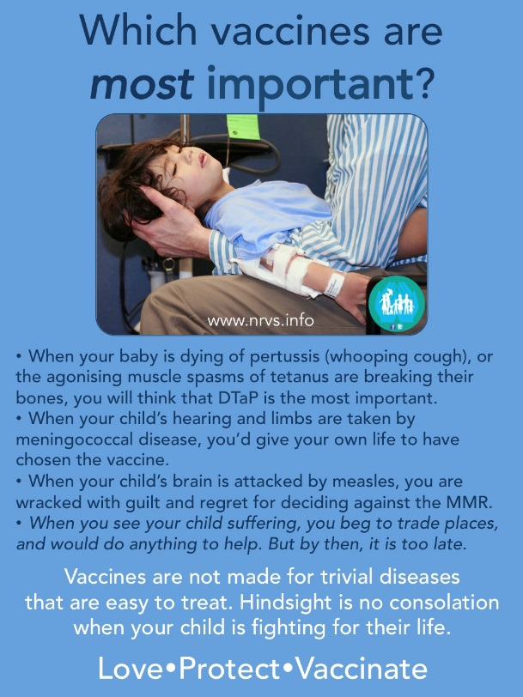

Myth #9 – But the vaccine schedule has never been tested.
- Yes, it has

Myth #10 – The vaccine court has paid out millions, that must mean there is vaccine injury!
- Vaccines are not 100% safe, but neither is anything else. ANYTHING can hurt you depending – people who claim this should also refuse anesthesia, antibiotics, Tylenol, etc.
- Between 2006 and 2016, 3,153,876,236 vaccines were given, 3727 claims in the court
  - That’s only 0.000118%
  - The decision of the court is not always scientific
  - Correlation does not mean causation
  - Anyone can report anything to VAERS.
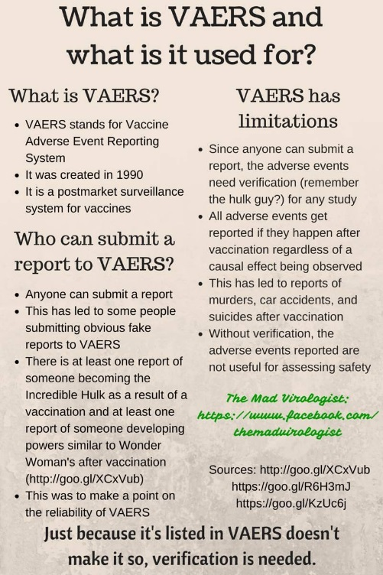
Myth #11 – The flu shot causes the flu.
- No, it doesn’t – sometimes you can feel crummy for a bit after getting a vaccine, that means your immune system is actually paying attention to the vaccine (when the immune system thinks there is a pathogen, the body will increase temp, etc). Some people just happen to get sick with the flu (sometimes you go get the shot because you know someone who got the flu and say “oh, I better go get the shot”, well you might have already been infected, remember correlation does not mean causation)
- Flu mist does shed the virus but there has been no confirmed cases of people getting the flu from this. However, as a precaution, someone on chemo is advised to stay away from people who just recently got vaccinated.

Myth #11 – The vaccine insert shows all sorts of adverse reactions and these will happen to your child.
- The vaccine insert is a legal document, not a scientific one.
- If someone claimed a reaction, it has to be put in the insert (doesn’t necessarily mean it was caused by the vaccine). Have you read the inserts to any other medication you’ve taken? – they’re all scary sounding….
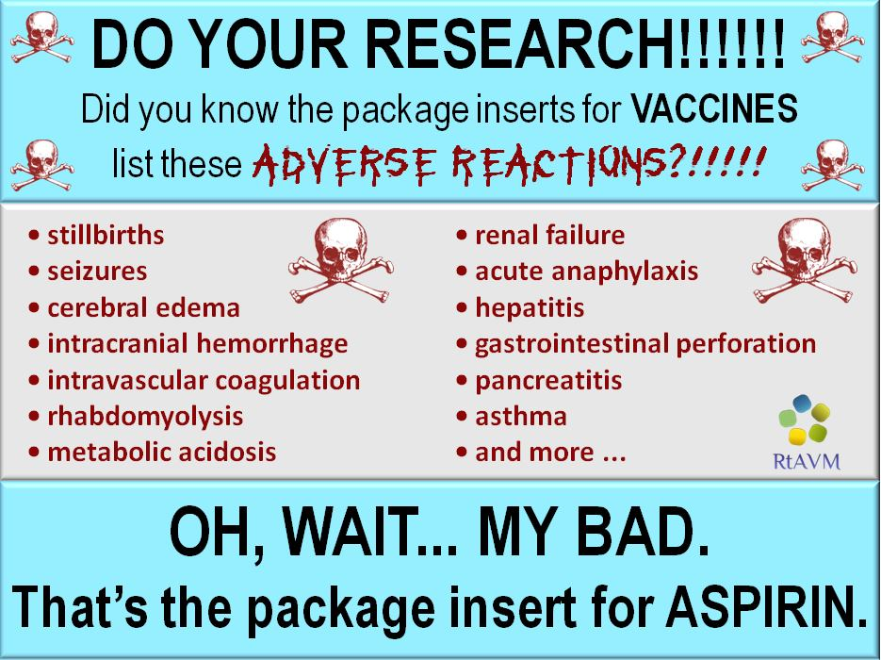

Myth #12 – Vaccine immunity wanes, natural immunity is better.
- This shows a misunderstanding of how our immune system actually works. Most of the myths on vaccines show people’s lack of understanding.
- When you gain immunity (whether through vaccination or natural exposure), your body produces memory B and T cells, that’s how you have protection. However, those cells only last for a couple decades (which is still a long time). That’s why elderly people get sicker easier and might need boosters. Also, that herd immunity we’ve talked about protect those whose memory cells are dying (if there are no kids spreading the illness throughout school, they won’t infect grandma and grandpa, either).

Myth #13 – The number of cases of the disease were falling before vaccines.
- Yes, sanitation and good medical practices were helping with some of these diseases in the early 1900s….but the number of cases were still significant.
  - Polio rates didn’t decline until after vaccine was introduced in 1955
  - Measles rates didn’t decline until after vaccine was introduced in 1963
  - Chicken pox rates didn’t decline until after vaccine was introduced in 1995

Myth #14 – No one has died from measles in the US since 2003.
- False

Myth #15 – Doctors even admit vaccines are dangerous.
- If you are referring to “doctors” on websites such as Physicians for Informed Consent then I would think twice about who you are listening to. A little research into some of these anti-vax movement “doctors” show they are not supported by an institution, some of them aren’t real doctors, and honestly, some of them are pure crazy!
- Every single major medical association in the entire world supports vaccination……every.single.one…….

Myth #16 – Vaccines cause seizures.
- True, but not the ones you are thinking about. Febrile seizures are caused by a fever. And if you’re immune system is checking something out, sometimes you can have a fever. However, they happen very rarely and are not the equivalent to a grand mal seizure

Myth #17 – Vaccines cause allergies, asthma and eczema.
- Multiple studies have been done and there is nothing to support this.

Myth #18 – Vaccines are a conspiracy for Big Pharma to make money.
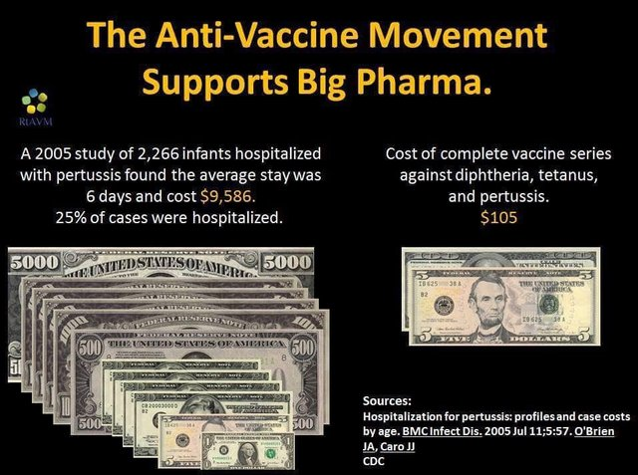

Myth #19 – Vaccination causes homosexuality.
- I won’t even go there……don’t know whether to laugh or cry

Myth #20 – Vaccines are injected directly into the bloodstream.
- So what if they were? Lots of things are – pain medicine, antibiotics, saline, sedatives
- But they aren’t – they are given as orally, subcutaneously, or intramuscularly

Myth #21 – You will expose yourself to foreign DNA.
- DNA is literally everywhere, in every cell of every living thing. Did you eat food? Did you breath air full of microbes? All that DNA is going into your body. Oh, and have you ever had a viral infection? – cause viruses inject their DNA directly into your cells……

Myth #22 – This one scientific paper does show possible adverse reaction…..
- It is important to be scientifically literate.
- One paper (or even a couple of papers) is not enough evidence
  - was the research just a preliminary study? Has more information come to light?
  - How old is the paper? Has there been other research since that has shown differently? When scientists get more data, a bigger picture emerges……

I took this idea for writing a document on these myths from Stories from the Trauma Bay (http://www.docbastard.net/) written on March 29, 2019. The document was very informative, thorough and entertaining due to some colorful language. Due to that colorful language, I couldn’t directly share the document with students and family. But it inspired me to write my own document to share with people when they had questions on vaccine safety.

