Cell Biology and Physiology
Exam 3 Study Guide

- Review all PowerPoints and parts of the chapters covered
- Define paracrine, autocrine and endocrine
- In signal transduction pathways, what is considered the first messenger? Second messengers?
- What is a kinase?
- What is a phosphatase?
- What is happening at each step with G-coupled protein receptors?
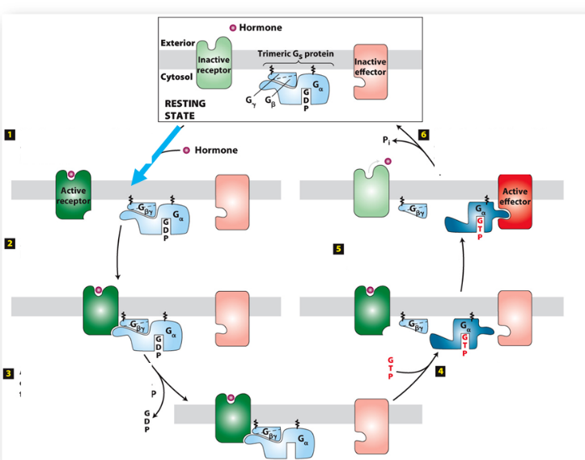
- Why is the epigenetic state of the cell so important when it comes to signal transduction?
- What are the 4 common types of receptors and cell signaling pathways?
- For each of these, refer to my drawings and be able to replicate and explain. (this is a big one)
- How are different MAP kinase pathways kept separate in a eukaryotic cell?
- What is cell polarity?
- What is actin? What is formin? What is Arp 2/3? How are actin filaments polymerized?
- What are myosins? How do they function? Do myosins move toward the (+) or (-) end of the actin filament?
- How does the myosin and actin work in skeletal muscle? What is a myofibril? Sarcomere? Z band?
- How does release of Ca2+ aid in muscle contraction?
- What are the 4 steps of cell migration?

