Cell Biology and Physiology Lab
Cell Passaging/Splitting Practice Worksheet Name:

When the cells become confluent, it is important to “split” them into new flasks with fresh media. When transferring cells to a new culture flask/dish, it is important to know the optimal density (which will vary among different cell lines). It is important to seed your new flask with fresh media at a cell number that is not too high or low. Therefore, you must do a cell count to determine the number of cells you have. This will allow you to determine how much media you need to dilute the cells to the optimum seeding density.

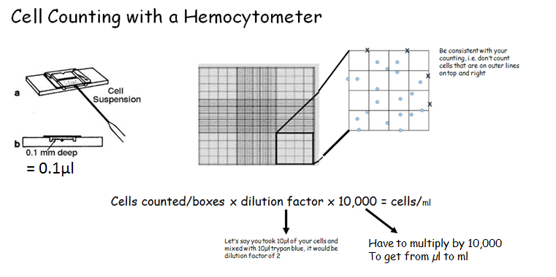

- You have trypsinized, spun down your cells and resuspended them in 5ml fresh media. You count and there are a total of 700 cells for all 4 boxes counted. You need to reseed your cells in flasks holding 5ml each. How many flasks do you need? ____7___

_700_cells/4 boxes x 2 x 10,000 = __3.5 X 10⁶_ / 5 x 10⁵ x _5___ml= ___35_ ml

35ml/5ml = 7 flasks Therefore, I will bring my 5ml solution up to 35 ml (add 30ml more media) and then put 5ml into 7 new flasks

- You have trypsinized, spun down your cells and resuspended them in 3ml fresh media. You count and there are a total of 420 cells for all 4 boxes counted. You need to reseed your cells in flasks holding 5ml each. How many flasks do you need? __________

- You have trypsinized, spun down your cells and resuspended them in 5ml fresh media. You count and there were too many cells so you dilute your sample with more trypan blue, dilution factor is now 4. You count and there are a total of 501 cells for all 4 boxes counted. You need to reseed your cells in flasks holding 5ml each. How many flasks do you need?__________

- You have trypsanized, spun down your cells and resuspended in 3mL of media. You dilute with trypan blue and your dilution factor is 3. You count and there are a total of 627 cells in 5 boxes counted. You need to reseed your cells in flasks holding 5mL each. How many flasks do you need? _________________

