Cell Biology and Physiology Lab
Cell Counting and Cell Staining Name:

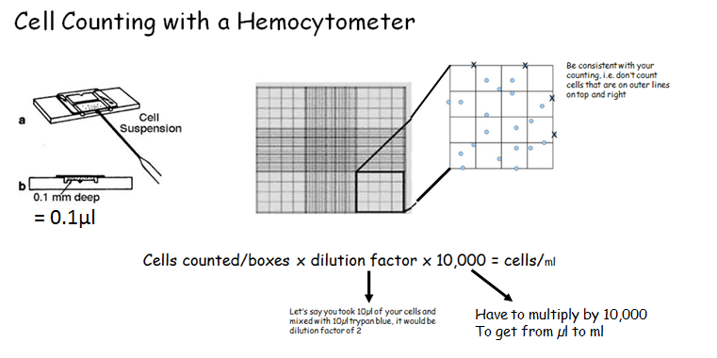

Simple Stain:
- Take 50µl of your cell sample and put in microcentrifuge tube 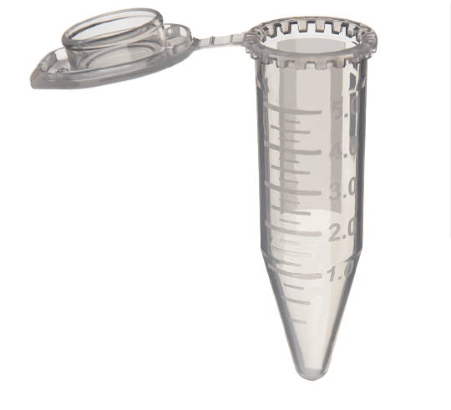
- Add 50µl of Trypan Blue (will stain dead cells)
- Immediately load some of the sample on the hemocytometer
- Count # of clear cells
  - What was your total cell count for 4 boxes? _______

  - ______cells/4 boxes x 2 x 10,000 = ___________ / 5 x 10⁵ x ______ml= _________ ml

Fluorescent Staining:
Fluorescence staining has a lot of advantages. Some animals have fluorescent pigments that are very useful in biology. One of these is the green fluorescence protein (GFP, from jellyfish). Fluorescence microscopy allows you to visualize living cells and tissues. The fluorescent stain can bind with structures within the cell allowing those structures to be better visualized with better resolution. You can use different colors to track distinct molecules at the same time.

We will be using InvitrogenTM Ready ProbesTM Cell Viability Imaging Kit, Blue/Green. NucBlueTM Live Reagent stains the nuclei of all the cells and can be detected with a DAPI filter. NucGreenTM Dead Reagent stains only the nuclei of compromised cells and can be detected using FITC/GFP cube.
- Add 1 drop of stain per mL
- Incubate for 15 minutes
- View using the EVOS

