Cell Biology and Physiology Study Guide
Exam 4 and Final

- Review study guides from previous exams for the comprehensive portion!!
- Microtubules
  - What is the major protein?
  - Where do microtubules originate?
  - Are the polar?
  - What are the associated motor proteins?
  - What is anterograde and retrograde transport?
- Label:
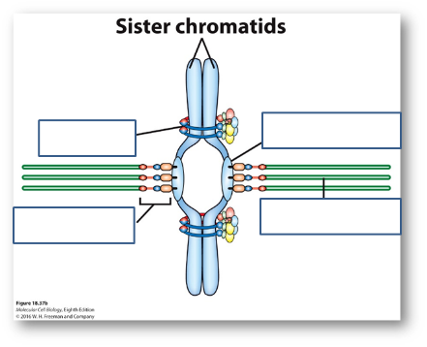
- Intermediate filaments
  - Are the polar?
  - Where do you find them?
  - What are lamins?
- Cell cycle – what are the 4 main phases?
  - What are mitogens?
  - What are cyclin dependent kinases? How do they function?
  - Explain what is happening here:
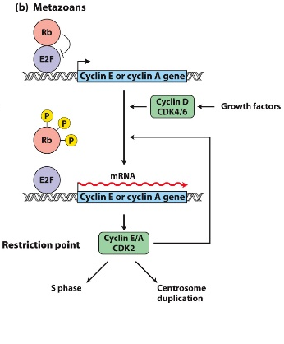

- Embryo development, in mice and humans, what is the 8-cell stage? What is the 16-cell stage? What is the blastocyst? What are the parts of the blastocyst?
- Where are embryonic stem cells located? What is pluripotent?
- What are adult stem cells? What is multipotent? What are examples found in humans?
- What are Par proteins?
- Apoptosis – genes involved in cell death encode proteins with 3 distinct functions, what are these?

