General Biology II Lab Worksheet
Exercise 2 – The Protists Name:

- Look at the following slides and match the pictures:

  - Protozoans:
    - Amoeba Slide #_____
    - Radiolarians Slide #_____
    - Globigerina Slide #_____
    - Ciliates – Paramecium, Stentor, Vorticella Slide # ______, _______, ______
    - Trypanosoma Slide #_____
    - Trichomonas Slide #_____
    - Plasmodium Slide #_____
  - Algae:
    - Green Algae
      - Spirogyra Slide #_____
      - Volvox Slide #_____
    - Euglena Slide #_____
    - Diatoms Slide #_____
    - Ceratium (dinoflagellate) Slide #_____

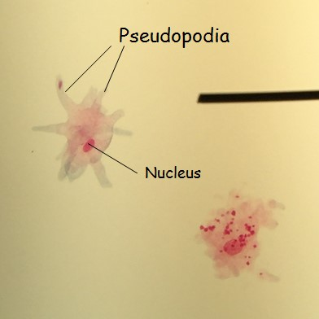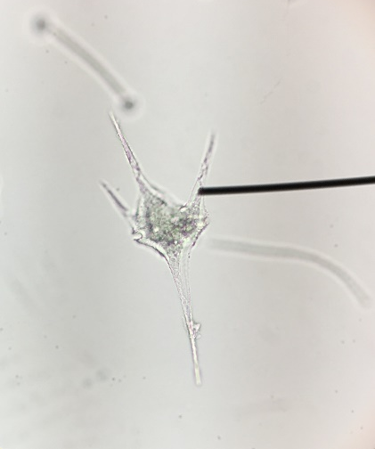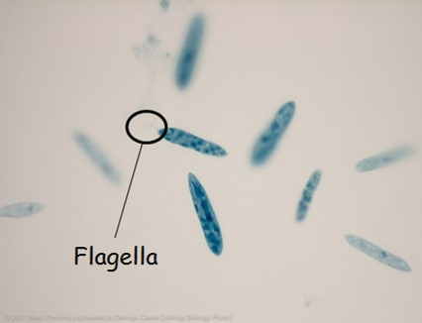

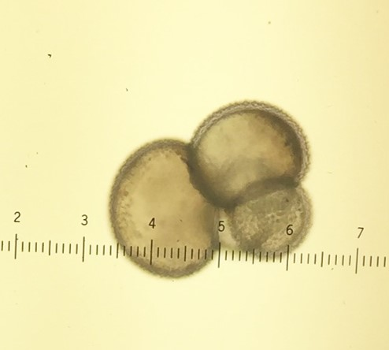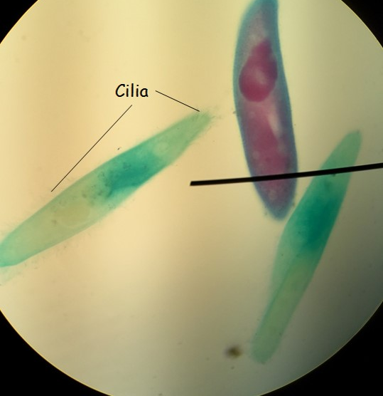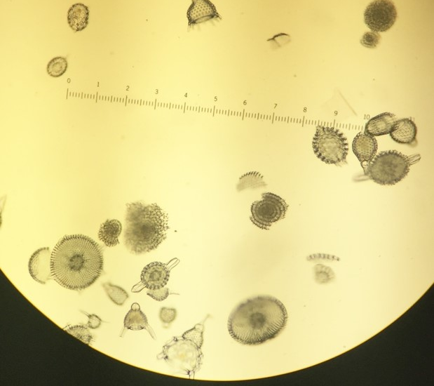

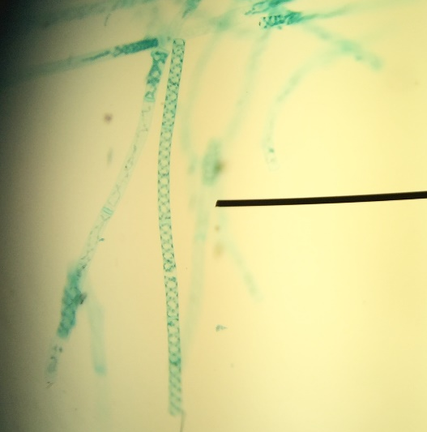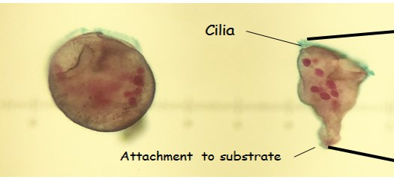

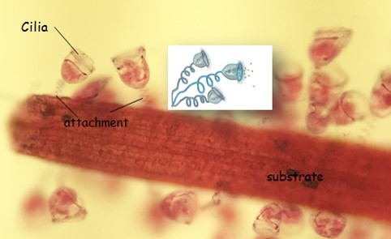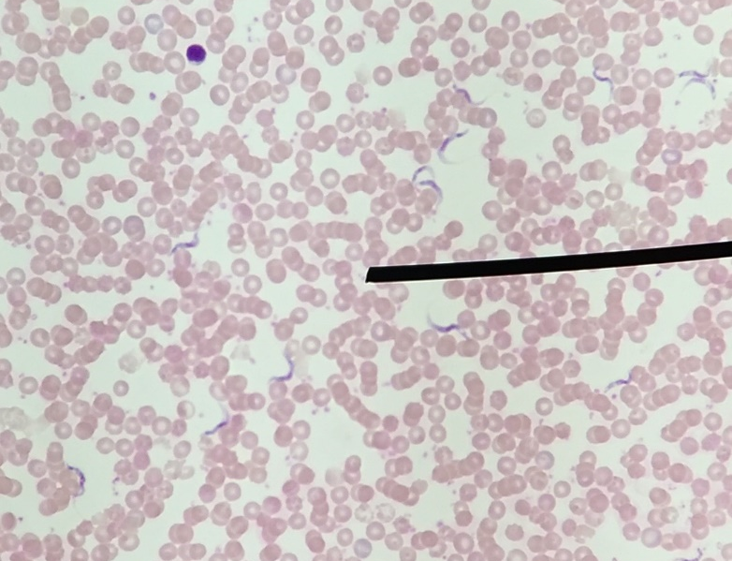

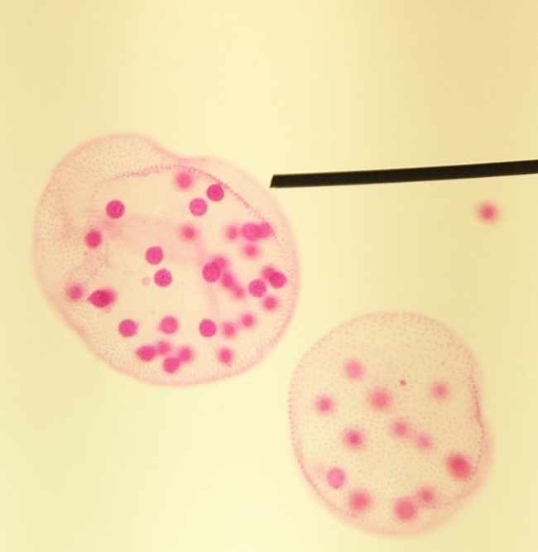

- Did you observe the specimens of algae that are displayed on the lab benches? ________

- Are the protists eukaryotes or prokaryotes? ______________________________

- What are photosynthetic protists called? ______________________________

- What are heterotrophic protists called? ______________________________
- Draw the phylogenetic tree of the eukaryotes:

- Were you able to find all of the microscopic protists using the microscope? _________ Did you label the pictures in your lab notebook? _______

- What are the macroscopic algae called? ______________________________
- Be sure to make flashcards to help you study. You will be required to identify all of these organisms.

