Biology for Health Sciences Lab (BSC 1020L)
Chemistry Overview (Molecular Model Lab) Name:

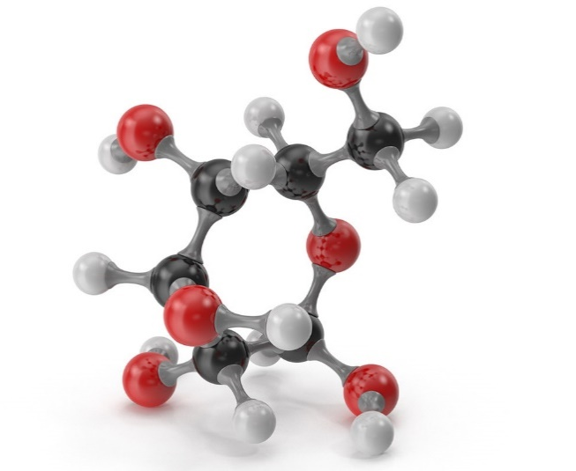Glucose Molecule

Atoms are the building blocks of all matter. Atoms of the same type are termed elements (example: hydrogen, carbon). There are over 100 known elements, each has a designated letter symbol on the periodic table. Elements come together to make larger molecules. Molecules made up of different elements are also called compounds.

The picture below is the basic structure of an atom (Figure 1). Atoms are made up of subatomic particles: protons, neutrons and electrons. Each different element has a certain number of protons (if you change the proton #, you change the element). Protons (+) and neutrons (neutral) are found in the atomic nucleus. Electrons (-) are found in orbitals (valence shells) surrounding the nucleus. The first valence shell holds 2 electrons. The rest of the valence shells can hold up to 8 electrons. An atom that has a full outer valence shell is stable (“happy”) and will not react. Atoms that have an incomplete valence shell will want to either give up their electrons, gain electrons or share them in a chemical reaction to become stable (that will lead us to talk about ionic bonds and covalent bonds later).
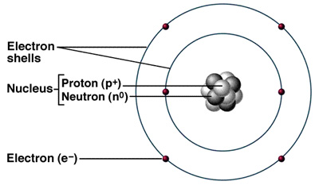

Figure 1. Basic structure of an atom.

Elements are listed on the periodic table. Each element has its own symbol (Figure 2). The atomic number is the number of protons. The atomic mass is the protons + neutrons. Atoms can change their number of neutrons, forming isotopes of that element. Therefore, atomic mass is listed as an average of all the common isotopes found in nature.
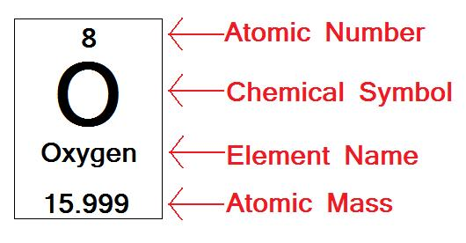
Figure 2. How elements are listed on periodic table.

Atoms will react with each other depending on how many electrons are in their outer shell. Remember, the first valence shell holds 2 electrons and every other shell holds 8 electrons. In an ionic bond, an atom will gain or lose an electron (Figure 3) to result in their outer shells being full. In a covalent bond, atoms will share electrons to fill their outer shells (Figure 4). Covalent bonds are stronger than ionic bonds. When we discuss cellular respiration, we will discuss how covalent bonds hold chemical energy that can be harvested when broken. The number of atoms a particular atom can bond with depends on how many electrons are in that outer shell. For instance, Hydrogen (H) has one electron in the first shell. Therefore, it can bond with one other atom so that it has 2 electrons. Or, it can give up that electron and become H+ (because it lost its negative electron but still has its positive proton) – it is now a hydrogen ion. Another example is Carbon (C). It has 4 electrons in its outer shell so it can bond with up to 4 other atoms.
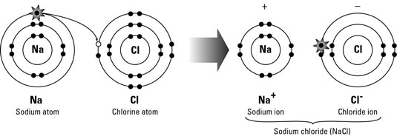
Figure 3. Example of an ionic bond.

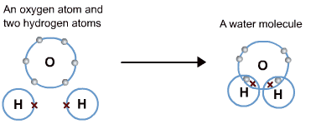
Figure 4. Example of a covalent bond.

Questions:
- What is the charge of electrons? _______________

- What is the charge of protons? ________________

- What is the charge of neutrons? _______________

- What is found in the atomic nucleus? __________________________

- How many electrons can be found in the first valence shell? _________

- How many electrons can be found in all of the other valence shells? _____________

- Atomic number equals number of _____________.

- Atomic mass equals the number of ________________ + __________________.

- What happens with an ionic bond?

- What happens with a covalent bond?

- How many electrons are in the outer shell of this nitrogen atom? _____ How many bonds can nitrogen make? ______
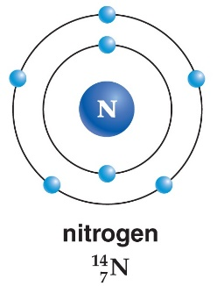
- How many electrons are in the outer shell of this phosphorus atom? ______ How many bonds can phosphorus make? ______
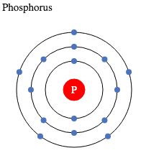

Molecular Modeling
One of the difficulties of studying molecular bonding is that you cannot see atoms and individual molecules. It is hard to imagine molecules using a two-dimensional drawing on your paper (Figure 5) because the electron shells are in a three-dimensional pattern (Figure 6).

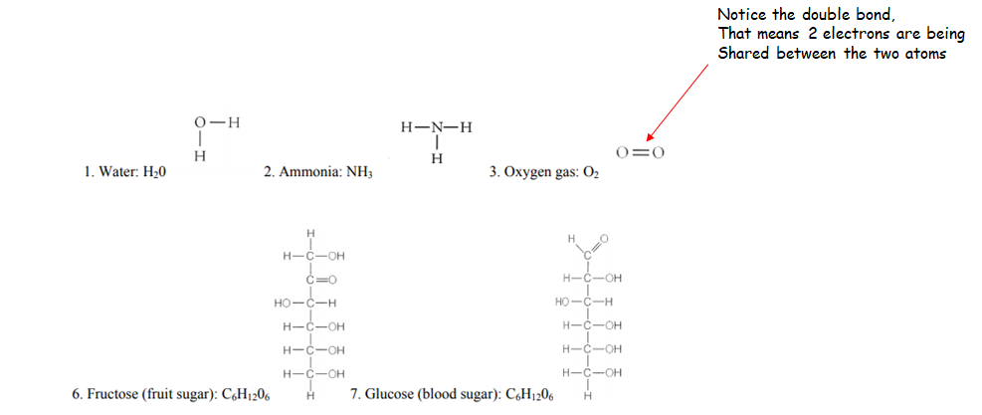
Figure 5. Molecules drawn in two-dimensional form.

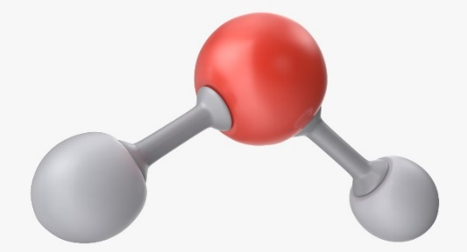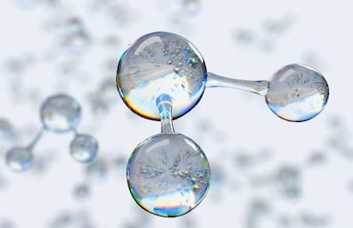
Figure 6. In reality, molecules are in three-dimensional form.

Using a molecular model kit allows you to see the three-dimensional bonds atoms form with each other. The balls are atoms, each color represents a different atom. The sticks are the bonds that are formed. Each atom has a particular number of holes (ranging from 1-4). This indicates how many electrons it needs to become stable. For instance, grab the Hydrogen atom, there is one hole because it has one electron and requires another one to equal two electrons in that first shell. Carbon has four holes because there are four electrons in its outer shell so it is looking to share four electrons to make eight in its out shell (Figure 7). A molecular formula shows the types of atoms and how many for a molecule (for example: Glucose is C₆H₁₂O₆, Carbon Dioxide is CO₂)

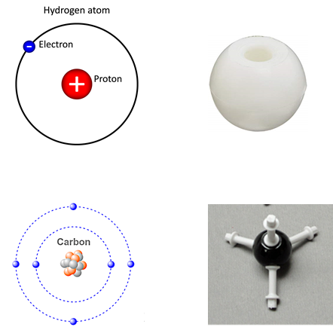
Figure 7. Comparison of atom drawing to molecular model kit.

Activity:
Using the molecular model kit, make the following molecules with a partner:
Oxygen Gas O₂
Carbon Dioxide CO₂
Water H₂O
Methane C₄
Glucose C₆H₁₂O₆
Ammonia NH₃

Remember to take pictures with your phone.

Questions:
- What do the number of holes in each ball in the model kit represent?

- What do the sticks represent?

