Biology for Health Sciences
Chapter 6 Worksheet Name:

- Why does biology need order?

- In order to maintain order, cells need a constant input of _________________.

- What are anabolic reactions?

- Are anabolic reactions endergonic or exergonic? _________________

- What are catabolic reactions?

- Are catabolic reactions endergonic or exergonic? _________________

- What is metabolism?

- What is potential energy?

- What is kinetic energy?

- ________________ energy is the energy needed for a reaction to get started. This energy can be lowered by use of ________________.

- Label:
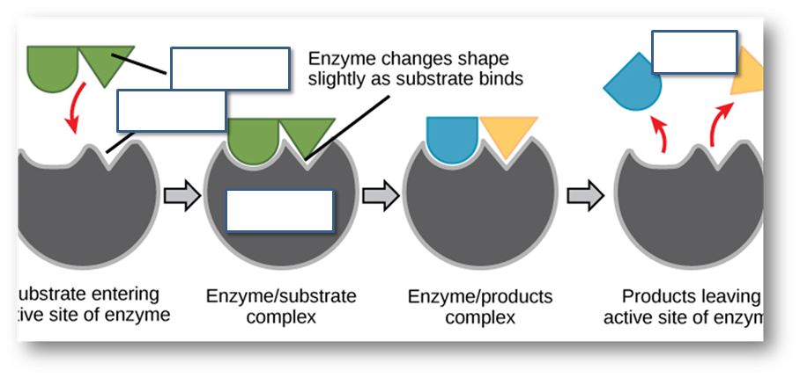
- Why is feedback inhibition important?

- What is the 1st law of Thermodynamics?

- What is the 2nd law of Thermodynamics? (these are physics laws)

- The ultimate source of energy for the planet is the _______.

- What is ATP?

- In a REDOX reaction, what does it mean to be reduced?

- In a REDOX reaction, what does it mean to be oxidized?

