General Biology for Health Sciences
Chapter 5 Worksheet Name:

- Label:
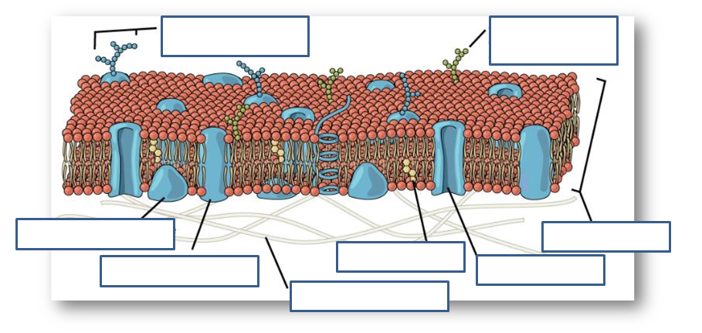
- What are glycoproteins?

- What are glycolipids?

- The lipids that make up a cell membrane bilayer are _______________________. The head is ______________ while the tails are hydrophobic.

- Proteins that span the lipid bilayer are __________________________________.

- Moving substances from an area of high concentration to lower concentration is called ____________ transport. Does this require energy? _____

- What is facilitated transport?

- Define osmosis.

- Is this an isotonic, hypertonic or hypotonic situation? Explain what is happening here.
- Is this an isotonic, hypertonic or hypotonic situation? Explain what is happening here.
- What is active transport?

- Does active transport require energy? ________

- What are the 3 types of endocytosis? Describe each.

