Biology for Health Sciences
Chapter 4 Worksheet Name:

- What is the cell theory?

- Are most cells very large or small? Why?

- What are prokaryotic cells?

- What are eukaryotic cells?

Use this picture for next couple of questions:
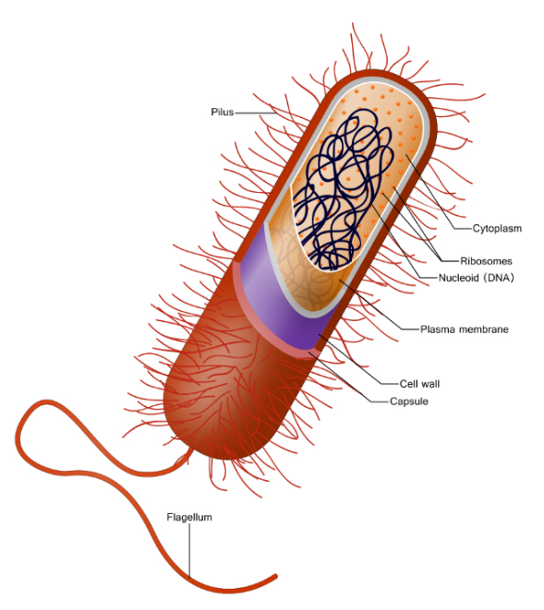
- Where do you find the DNA in a bacteria (prokaryote)? __________________

- What do the ribosomes do in bacteria? ______________________________

- What is the cell wall made of in bacteria? ____________________________

- What does a capsule do for a bacteria? _______________________________________

- How many chromosomes do bacteria have? __________

- Name a function of the following eukaryotic organelles:
  - Nucleus: ___________________________________________

  - Ribosome: __________________________________________

  - Rough ER: __________________________________________

  - Smooth ER: _________________________________________

  - Golgi Apparatus: _____________________________________

  - Lysosome: __________________________________________

  - Cytoskeleton: ________________________________________

  - Central Vacuole in Plants: _______________________________

  - Mitochondria: _______________________________________

  - Chloroplasts in plants: _________________________________

- What is the cell wall in plants and protists made up of? _____________________________

- Do animal cells have cell walls? _____________

- What is extracellular matrix?

- What is the endosymbiosis theory?

