Biology for Health Sciences
Chapter 3 Worksheet Name:

- Why is carbon considered the perfect “tinker toy”?

- What are the 4 groups of macromolecules?
  - ____________________________

  - ____________________________

  - ____________________________

  - ____________________________

- What are hydrocarbons?

- What are functional groups?

- What is a monomer?

- What is a polymer?

- Describe what is happening here:
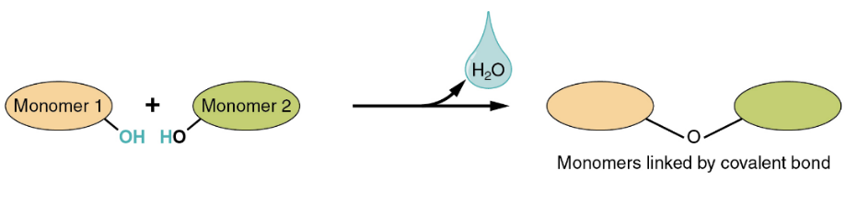

- Describe what is happening here:
- Carbohydrates are made up of what elements? _________________________________

- What is the monomer of carbs? ______________________

- What is the covalent bond called that links monomers in carbs? _____________________

- Give an example of a monosaccharide: _____________________

- How many carbons are in a pentose sugar? ______

- What are the 4 major classes of polysaccharides?

- What is the monomer of proteins? ___________________

- What is the covalent bond called that links monomers in proteins? _____________________

- Label the parts of the basic amino acid:
  - ___________________________
  - ___________________________
  - ___________________________
  - ___________________________
  - ___________________________

- How many amino acids are there? _______

- What are the 4 levels of organization of a protein?

- What can denature a protein to make it nonfunctional?

- What is the monomer of a nucleic acid? ________________________

- What is the covalent bond called that bonds monomers in a nucleic acid? _________________

- A nucleotide is made of a _______________________, ______________________, and __________________.

- In DNA, the sugar is ______________________.

- In RNA, the sugar is ____________________.

- What are saturated fatty acids?

- What are unsaturated fatty acids?

