Biology for Health Sciences
Chapter 21-23 Name:

- Are viruses alive?

- Viruses are species specific and _______________ specific.

- A virus (virion) is made up of a __________________ and ____________________.

- What is a bacteriophage?

- Will antibiotics work for a viral infection? ____

- What is a temperate virus?

- What are prions?

Bacteria:
- The 3 Domains of Life are _________________, _________________ and _______________.

- The 2 Domains of bacteria are _________________ and ____________________.

- What are the 3 basic bacteria shapes? __________, ___________, __________

- Bacterial cell wall is made up of _______________________.

- What is the purpose of the flagella?

- Some bacteria have endospores, what does the endospore do?

- Some bacteria cause disease. However, many bacteria are beneficial. List some of examples of the benefits of bacteria:

Protists:
- What Domain are protists in? ____________________

- Protists that are heterotrophic are __________________.

- Protists that are autotrophic are __________________.

- Unicellular algae are ______________________.

- Multicellular algae are ________________________.

- Identify: _________________
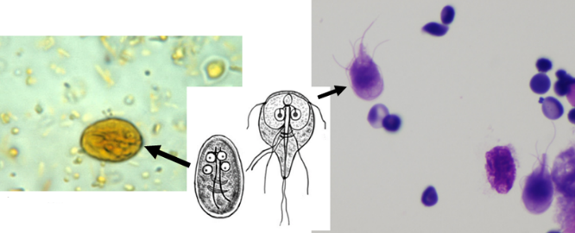
- Identify: _________________

- Identify: __________________
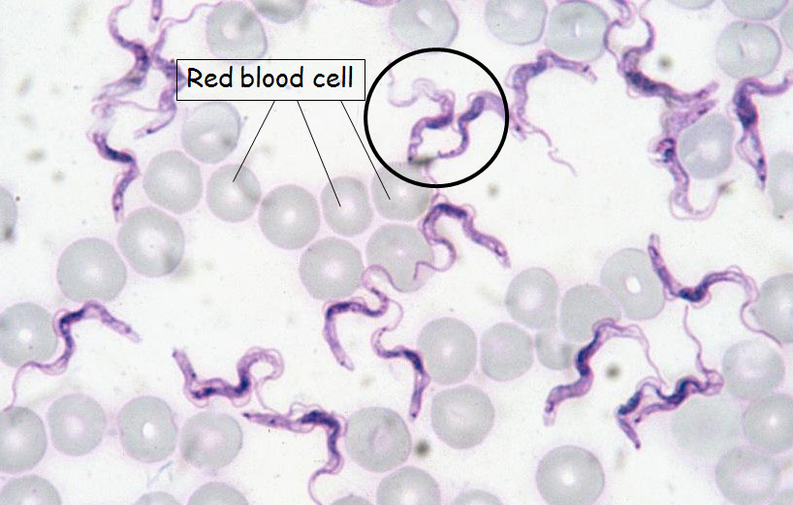
- Identify: ___________________
