Biology for Health Sciences
Chapter 15 and 16 Worksheet Name:

- What is the Central Dogma?

- The sequence of DNA specifies the sequence of _________________, the building blocks of proteins.
- When a particular gene is activated, the DNA is __________________ into a piece of mRNA, the mRNA is then ________________ into an amino acid sequence.

- In mRNA, every 3 nucleotides is a __________.

- Each codon codes for a particular _________________.

- How many amino acids are there? _______
- On what organelle does translation happen? _____________

- What is the function of the tRNAs?

- Label:

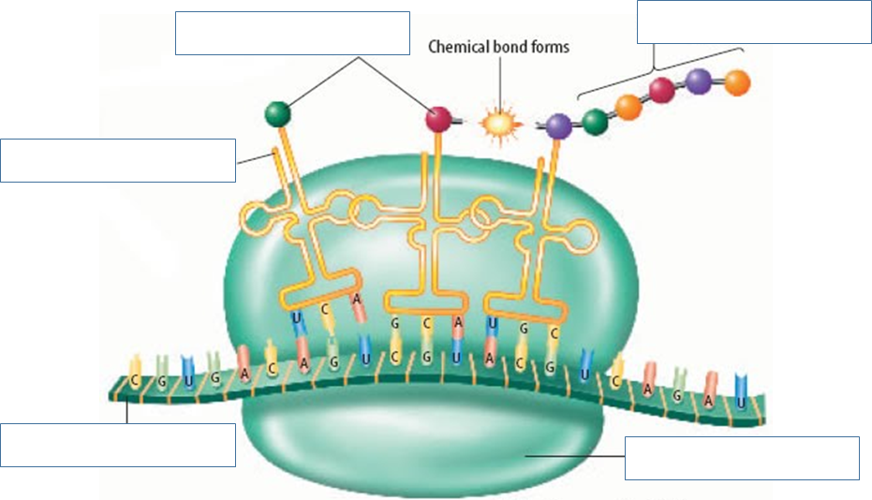
- Draw the figure I drew on Slide 15 on Overview for Eukaryotic Cells (on the back of this paper).

- What happens when a mutation occurs in the DNA?

- What can cause mutations?

