Biology for Health Sciences
Chapter 12 Worksheet Name:

- Define phenotype:

- Define genotype:

- In a person that has blue eyes, what is the phenotype? _______________ what is the genotype? ______

- Define homozygous:

- Define heterozygous:

- Define allele:

- With some genes, one allele might be dominant over another recessive allele (for instance, in humans, the brown eye gene is dominant over the blue eye gene). The dominant gene will then be expressed. In this example, circle the dominant allele: B b

- Do a Punnett square for the following individuals: mother is heterozygous for Brown eyes, father is homozygous for blue eyes:
Remember B=brown; b=blue
What percentage of their offspring have a chance of having blue eyes?

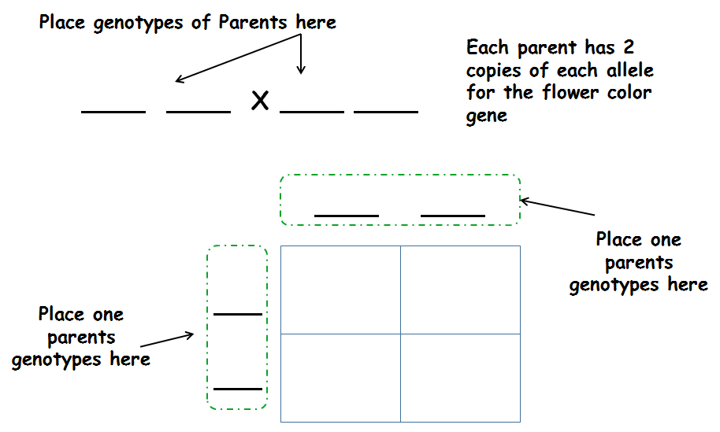

- Is question #8 an example of a monohybrid or dihybrid cross? ______________

- What is a pedigree analysis?

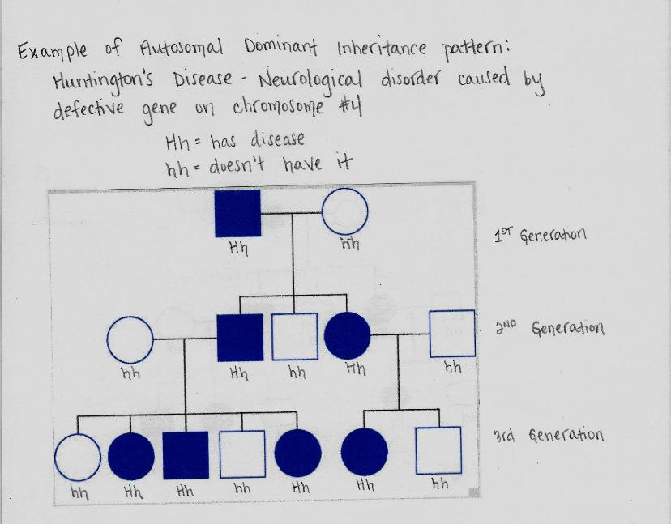
How many individuals in this family have Huntington’s disease? _______
How many individuals are female? ______

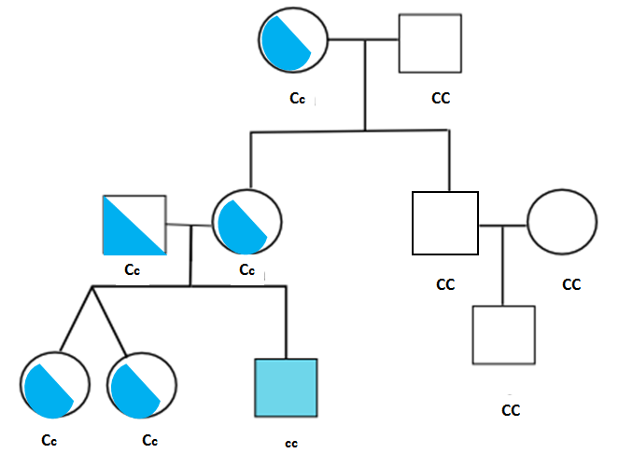
Does anyone in the 2nd generation of this family have the disease?_____ Why?

- In peas, round (R) is dominant over wrinkled (r) and yellow (Y) is dominant over green (y). Perform a dihybrid cross of the following RrYy x RrYy.

- What is polygenic?

- Is human height determined by one gene? _______
- This is an example of _______________________________>
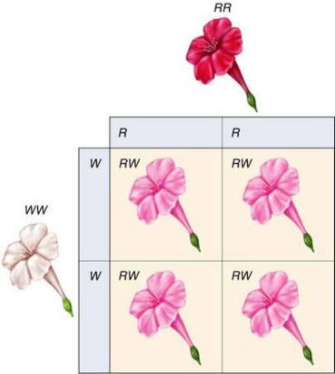

- Human Blood Type AB is an example of __________________________________.

- What is an X-linked human disease?

- If a female who is a carrier for color blindness has a child with a male who is not colorblind, what are the chances they will have a son who is colorblind? Make a Punnett square.

