Biology for Health Sciences
Chapter 11 Worksheet Name:

- 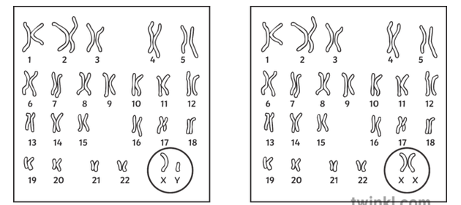
These are human karyotypes. Label which one is female and which is male.
Notice that we have 46 chromosomes, 23 homologous pairs, 2 sets. When we form gametes to donate to offspring, we want to make sure there is only one set (one of each chromosome).

- Does the DNA replicate before meiosis just like mitosis? _______

- How many divisions are in meiosis? _______

- What is the purpose of meiosis?

- Gametes are ______________ and ______________. Gametes contain how many sets of chromosomes? One or two (circle one)

- Complete this sentence: In Meiosis I, ________________ chromosomes are separated; in Meiosis II, _________ chromatids are separated.

- Label:
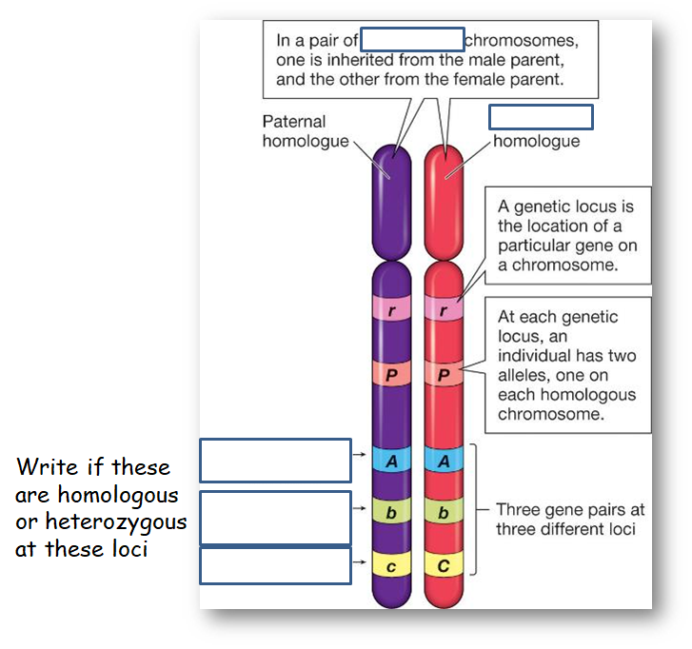
- What is happening at the blue line?
- List the stages of Meiosis I AND describe what happens at each stage:

- List the stages of Meiosis II AND describe what happens at each stage:

- Meiosis that produces eggs is called _____________________________.

- Meiosis that produces sperm is called ____________________________.

- What is nondisjunction?

