Biology for Health Sciences
Chapter 10 Worksheet Name:

- A ________ is the basic unit of life.

- Before cell division can happen, the _______ must replicate.

- How many chromosomes do prokaryotes (bacteria) have? _______

- Bacteria divide by a process called __________________________.

- With Eukaryotes, cell division is more complicated. Why?

- Mitosis is cell division used for ___________________ and __________________.

- Meiosis is cell division used for ______________________________________.

- What is a karyotype?

- How many chromosomes do humans have? _______

- Do all species have the same number of chromosomes we have? ______

- What is diploid? _______________________________ What is our diploid #? _______

- What is haploid? _______________________________ What is our haploid #? _______

- Label:
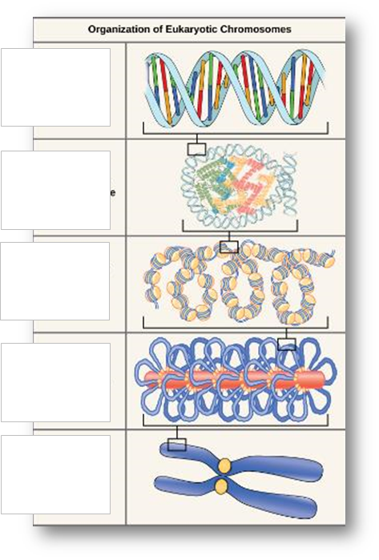
- Label:
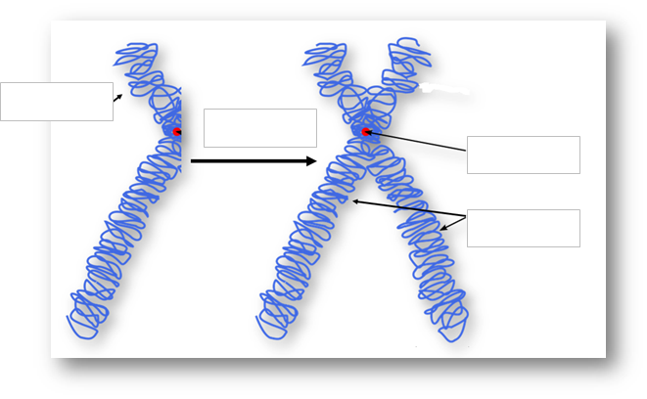
- Draw the cell cycle.

- The 2 Main Stages of the Cell Cycle are:
  - ____________________________

  - ____________________________
- Interphase is divided into what stages?
  - ____________________________

  - ____________________________

  - ____________________________
- Mitosis is divided into what stages?
  - ____________________________

  - ____________________________

  - ____________________________

  - ____________________________
Know what happens at each stage. Be sure to look at pictures of each stage and be able to identify.
For instance, what stage is this?
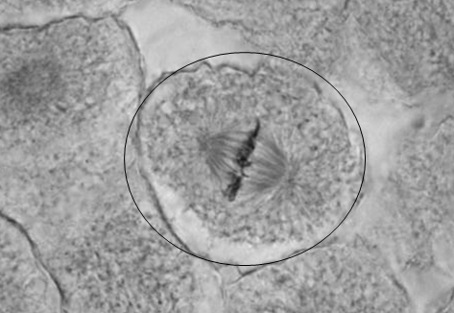
- What is cytokinesis?

- What is G₀?

- Why is it important to have checkpoints with mitosis?

- What are proto-oncongenes?

- What are tumor suppressor genes?

