Blood Cell Stain Wright-Giemsa Stain
Cell Biology & Physiology Lab

Blood Smear Fixation:
- Streak thin (approx. one cell thick) smears across a sterile slide by means of a second slide or cover glass.
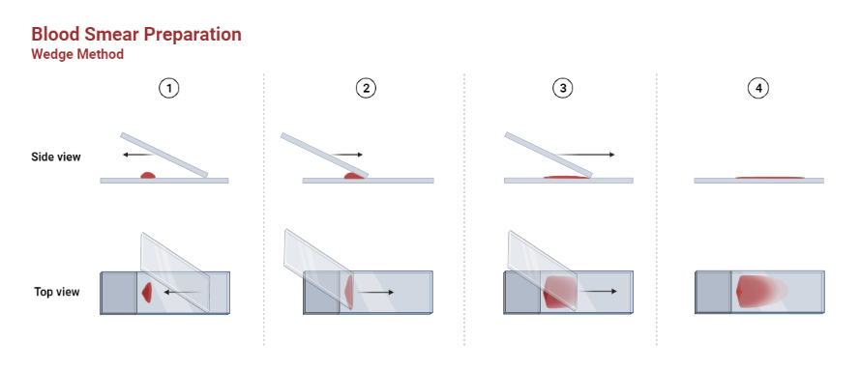
- Air dry.
- Fix in 100% methanol for 5 minutes.
- Air dry.

Staining:
- Place 1.0 ml of the Wright-Giemsa Stain upon the smear, in sufficient quantity to cover the entire surface, for 3-4 minutes.
- Add 2.0 ml distilled water or Phosphate Buffer, pH 6.5 and let stand twice as long as in step 1.
- Rinse stained smear with water or the Phosphate Buffer, pH 6.5 until the edges show faintly pinkish red.
- The film is allowed to dry in the air. The preparation may be blotted gently to hasten drying.
- Permanent mounts can be made with mounting medium.

Stain Results:
Erythrocytes | Pink-Tan
Eosinophiles | Red
Lymphocytes: Granules | Red-Purple
Lymphocytes: Cystoplasm | Blue
Neutrophils: Granules | Purple-Pink

